## horizontal line

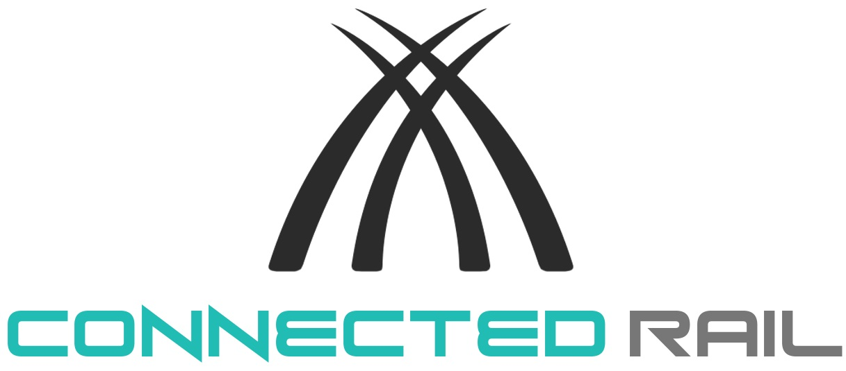

ConnectedRail

13/05/2019

James Hunt, Joseph Kilbane, Reece Davies & Struan Sharpe

PRCS252, Integrating Project Group L

Computer Science

School of Computing, Electronics & Mathematics

Faculty of Science & Engineering

University of Plymouth

# Introduction

This document will explain the method of approach to producing an integrated system for a hypothetical business that provides a means of transportation. It was agreed upon to create a system that specialises in train travel, due to its simplistic nature of having specified stops and bidirectional routes. This document will also state whom the system has been developed for, as the company is also required to manage the business functions using this system.

## What is ConnectedRail?

The client in this scenario is Connected Rail; ConnectedRail is a bespoke, full-stack software system designed and developed by computer science students at the University of Plymouth. ConnectedRail encompasses multiple popular platforms including web, desktop and mobile. These applications all link back to one central database where all interactions are controlled via a web-hosted API.

The web application has been implemented using *PHP, HTML, JavaScript* and *CSS*. The desktop application has been implemented in *Java*, utilising the popular framework *Swing* for user-interface design and development. The mobile application has been developed using *Xamarin* (a popular cross-platform framework built on top of Microsoft’s *C#*). The API has been implemented using a database-first approach (meaning the API has been implemented by transferring references from the pre-existing database) and has been built in *ASP.NET* (another popular *C#* framework designed for web development). Lastly, the database has been built using powerful Oracle software such as *PLSQL* and *SQL Developer*.

## What does ConnectedRail do?

ConnectedRail is a complete software package allowing everything from the booking of train tickets on the passenger’s end, to the management of staff accounts on the administrator’s end. Each platform provides unique features specifically relevant to the end user of that application. The administrator’s application is where most data entry and management takes place.

The administrator (via the web application) handles: staff accounts, train stations and their locations, journeys between the different stations and the staff members working said journeys, companies along with their trains and carriages, passenger accounts and lastly passenger bookings.

Members of staff (via the desktop application) are able to: access their account, view the shifts that they are working, view journeys with in-depth detail and other relevant passenger data.

Customers (via the mobile application) are able to: access their accounts and browse relevant journeys /place bookings that meet their time requirements.

## Who is ConnectedRail for?

ConnectedRail is designed for use by the staff of individual train stations. For example, Plymouth Central Station could take advantage of ConnectedRail to help their staff organise shifts etc. Theoretically, when a company signs with ConnectedRail, they become a new location and are added to the mobile application where ConnectedRail customers can book tickets to that location. Then, with this new software, the station can manage the train companies passing through, the trains and carriages associated with those companies and locations that customers can currently travel to from their station.

# Project Management

## Organising and maintaining an efficient workflow

This project contained a group of four members; and therefore, it is crucial that everybody is well-informed of the situation and understands their responsibility within the project. As a result, it was required that each member would be assigned designated tasks to coordinate the workflow. Once all four members were equated with each-other, a short but brief discussion occurred; in which, what would be the best method of approach and what was the scenario? Following this, all members worked together to overcome the initial challenges for the business; in particular, creating the functional requirements of each user and normalising all values for the database and ERD. It was arranged amongst us who would develop which aspects for ConnectedRail. Furthermore; a weekly meeting was held on Wednesdays at a minimum, in which we discussed our progress with our particular development area. It allowed everybody the opportunity to understand where they needed to be, and what the next task would be. It also allowed for group members to help one another if there were any issues; such as syntax errors.

## Team Work

During development we fully switched to Slack, which is a professional messaging application used in industry. In this, it is clear that communication was poor with particular members of the team; even though every possible effort was made, from Facebook to email and using the @ function to ping the person directly. We implore you to check Slack, we have sent an invitation to it to Shirley. During the last week tensions arose within it when marks were claimed. Initial API development lacked any overall progress, and this had heavy knock on affects to James and Joseph as they were wanting to develop their side of the applications promptly due to wanting to deliver a software package they were proud of. The only benefit to this negligible API progress was James and Joseph were able to spend a large amount of development time on the HCI elements of their respective applications.

Work ethic was strong with James and Joseph, Reece had large amounts of important external events which was recognised by not only the team but mentioned in meetings when he was unable to attend. Reece did display commitment to the project by spending long hours on development in a platform he was new to but still delivered a very strong application. Struan was incredibly hard to get hold of at the start of the project however he started interacting to a more helpful level nearer the deadline. Several work items for Struan had to be taken over by other members of the team, notably James doing the API for him and some UML diagrams, Joseph inserting 95% of the test data and a portion of the UML diagrams as well. Additionally, tasks given to Struan on software development areas like doing Junit tests unfortunately did not occur, this was completed by the previous task owner. James and Joseph did display a heavy commitment to the project by going in to fix issues on the weekend in the mornings on regular occasions so progress would not be hampered. Both seeking a meeting with David Walker to improve the HCI on the applications they were developing, Reece gave draft layouts that were also shown and discussed in the meeting. James has delivered a website that astounded the rest of the team with its features, style and sheer pace of work. Joseph has delivered a very strong and technical staff application that focuses heavily on the touch screen environment HCI elements it will be used in. Heavy technical and logic support was provided by James and Joseph as well to help development. Struan was asked to help on the mobile, within 2 days of the deadline he did start to help Reece to some extent. The issues came from styles of work, most of the team wanted to get it done way before the deadline to work on issues, while others did not work in this fashion.

Overall because of this slight lack of full commitment to the project tensions were high in the project closure meeting, due to lack of work completed and the hindering causes by it.

## Main points from the project closure meeting:

As of the final project meeting, this was the overview of our GitHub repository. This screenshot shows the total number of commits per contributor, alongside with a short-range frequency chart with their online activity for the past two months. An additional screenshot is also displayed, showing the data two weeks after the meeting (Monday 6th May 2019).

## 

Additionally; the software applications had not been concluded yet, as there were some aspects that can be changed or developed further. However; a lot had been accomplished, and proves that our group had been successful. The closure meeting particularly focused on key dates, and what needed to be accomplished prior to the deadline. For instance; a presentation is required by each group taking part in this module. And therefore, we discussed how the slideshow would look, and who is responsible for each section. We concluded that it would be fitting for each member to create the slides for the section they specifically developed; as they would best understand the code and its functionality.

## How did plans change along the course of the project?

Fortunately, there were no major problems in our group that would sabotage the end result of the project. Most of the team worked efficiently and contributed. However; there was one issue that occurred with other groups partaking in this project. Due to our limited experience with developing/maintaining and API, it therefore made it somewhat challenging to create one with little knowledge. Furthermore; this complication meant that more than the allocated time was spent working on the API, as opposed to the software applications. This caused a slight issue for when developing particular aspects that needed to be connected to the database; for example, hard-coding these sections may potentially jeopardize the functionality of a specific page/layout further on in development. Fortunately, this did not occur; only loss of time was an effect of this dilemma.

## Review of risk analysis (were risks identified and planned for correctly)?

Of course, no group would want major implications to occur mid development, and therefore conducting a risk analysis would be incredibly beneficial to the team. Sadly, we did not create a formal risk analysis document, due to the potential amount of time that we believed it would contain. Additionally, we could have organised an already made risk analysis, and thus we would be prepared in the case of a complication. In terms of what was done; if we had any particular problem, we would contact a lecturer for advice and guidance on how to eliminate any and all issues. This was mainly about the initial API issues. This could have been structured better as it means relying on someone else, as opposed to fixing the problem independently as a group, we did step in before a lecturer did a section of the API for us as we thought it could hinder marks. This is something that we would have done differently if given the chance.

# Requirements Analysis & Design

## The product backlog for ConnectedRail:

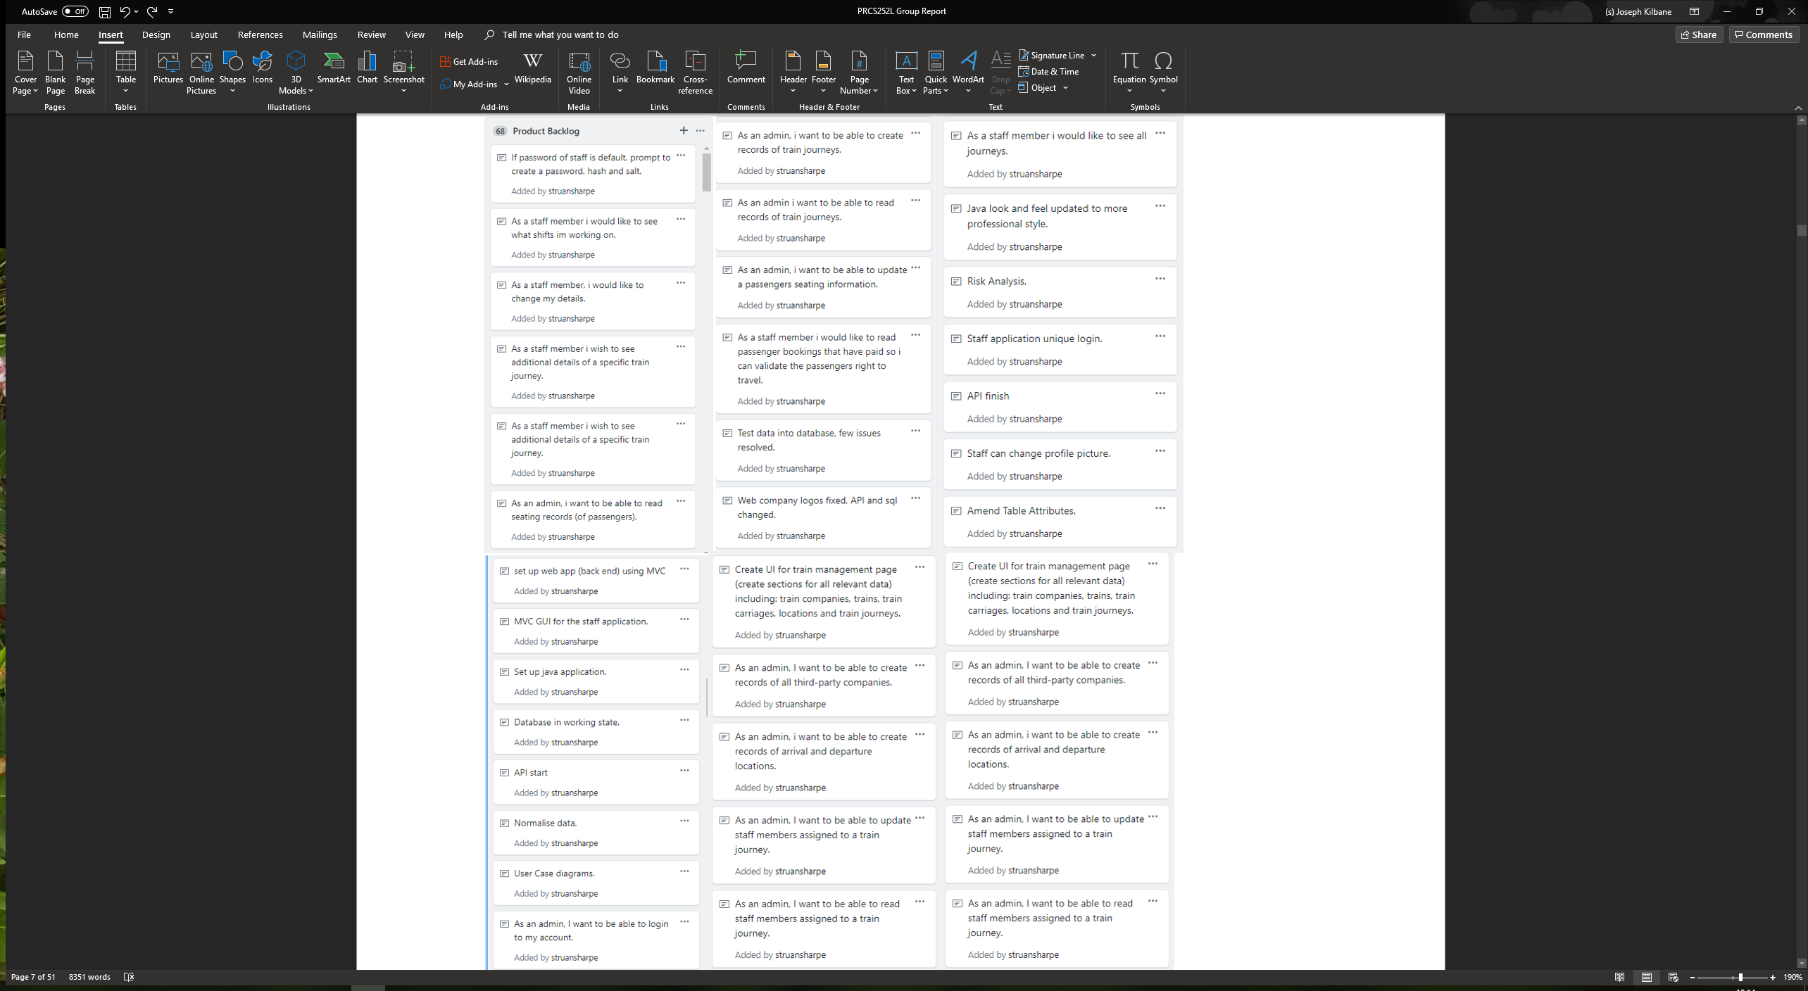

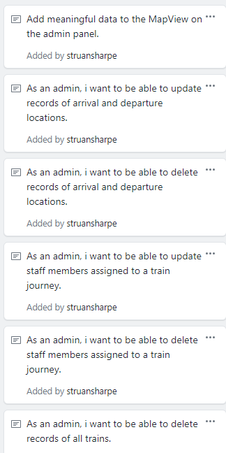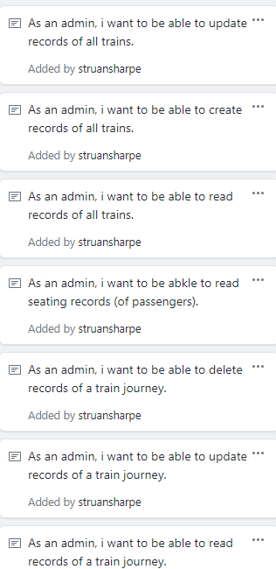

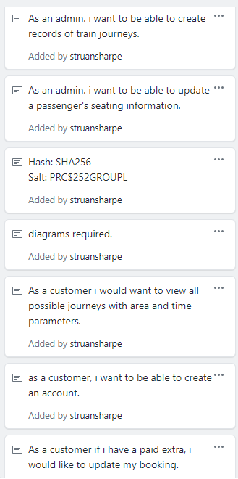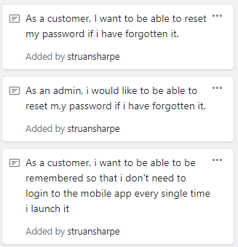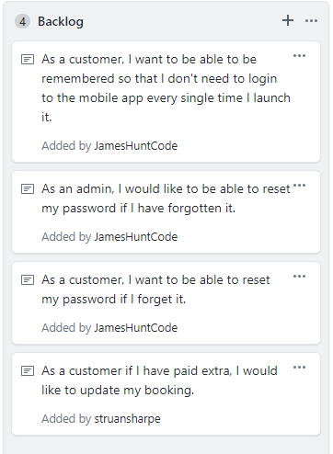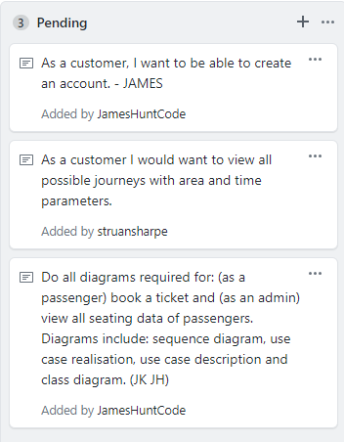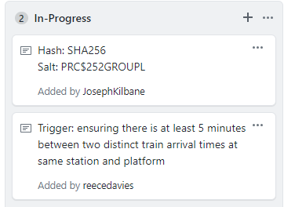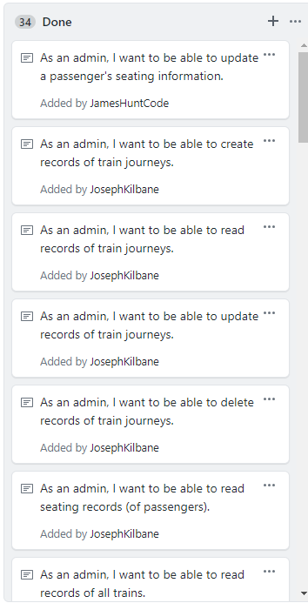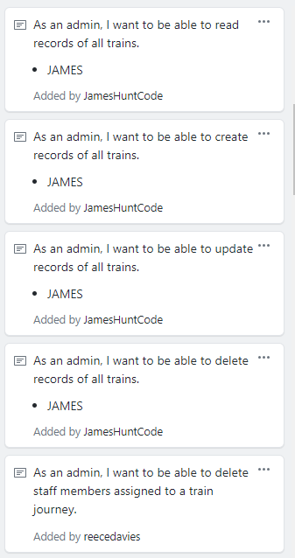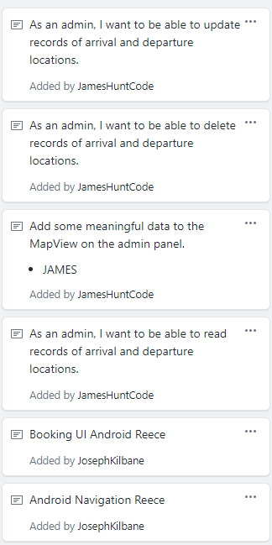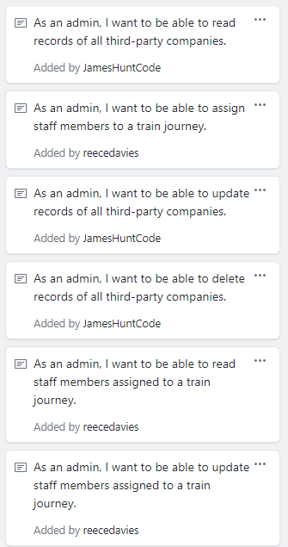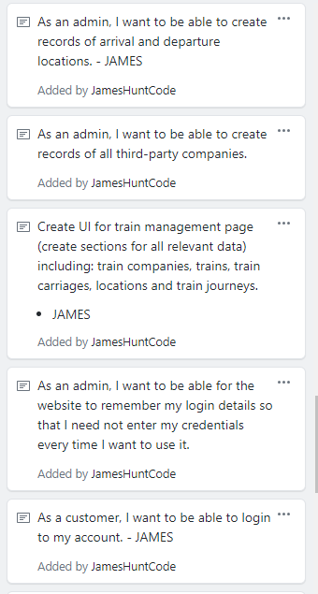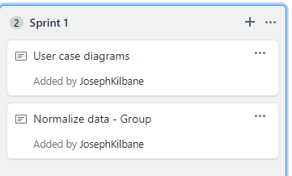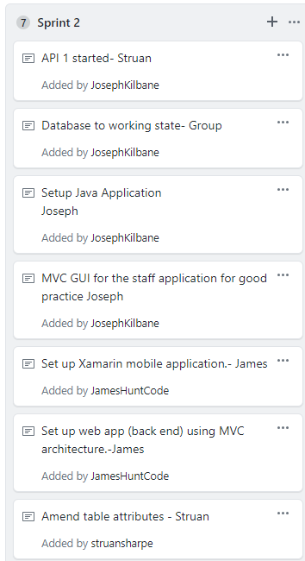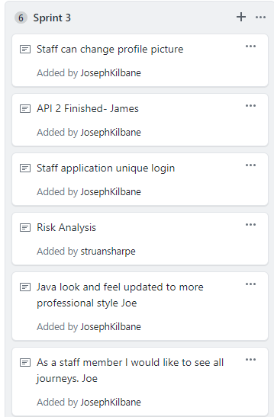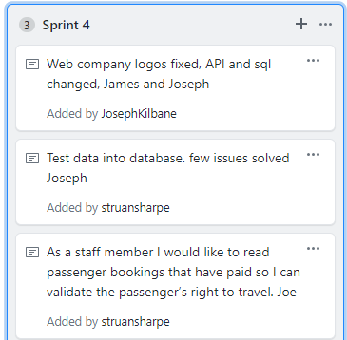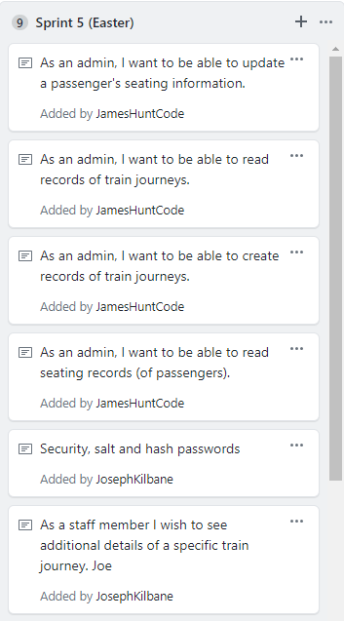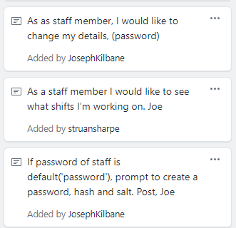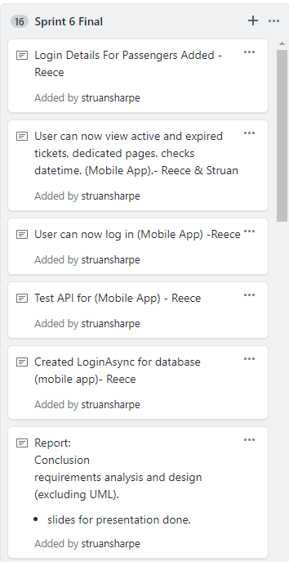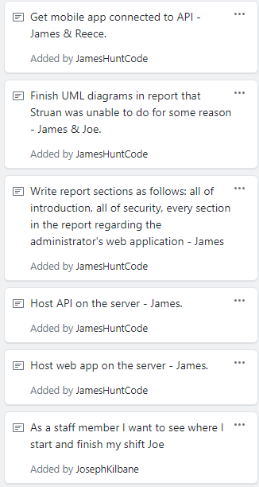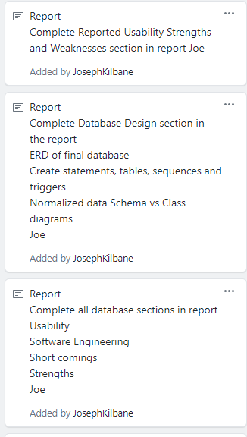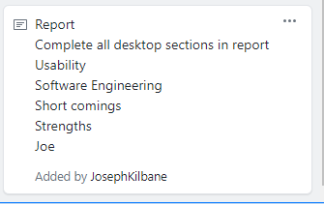

## Use case model (how user stories have been implemented):

Please see how each user story was implemented underneath the diagram depicting the user story itself.

## UML diagrams for four selected use cases:

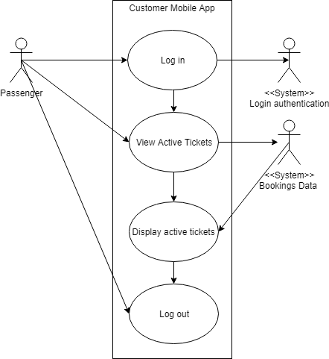

This is a use case depicting a Passenger logging into the system through the customer mobile application. When the user is logged in they can request to view active tickets, once the system has displayed the desired information the Passenger logs out.

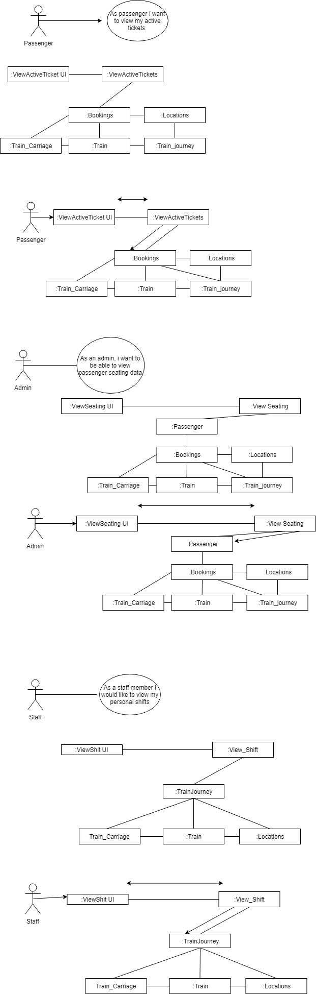

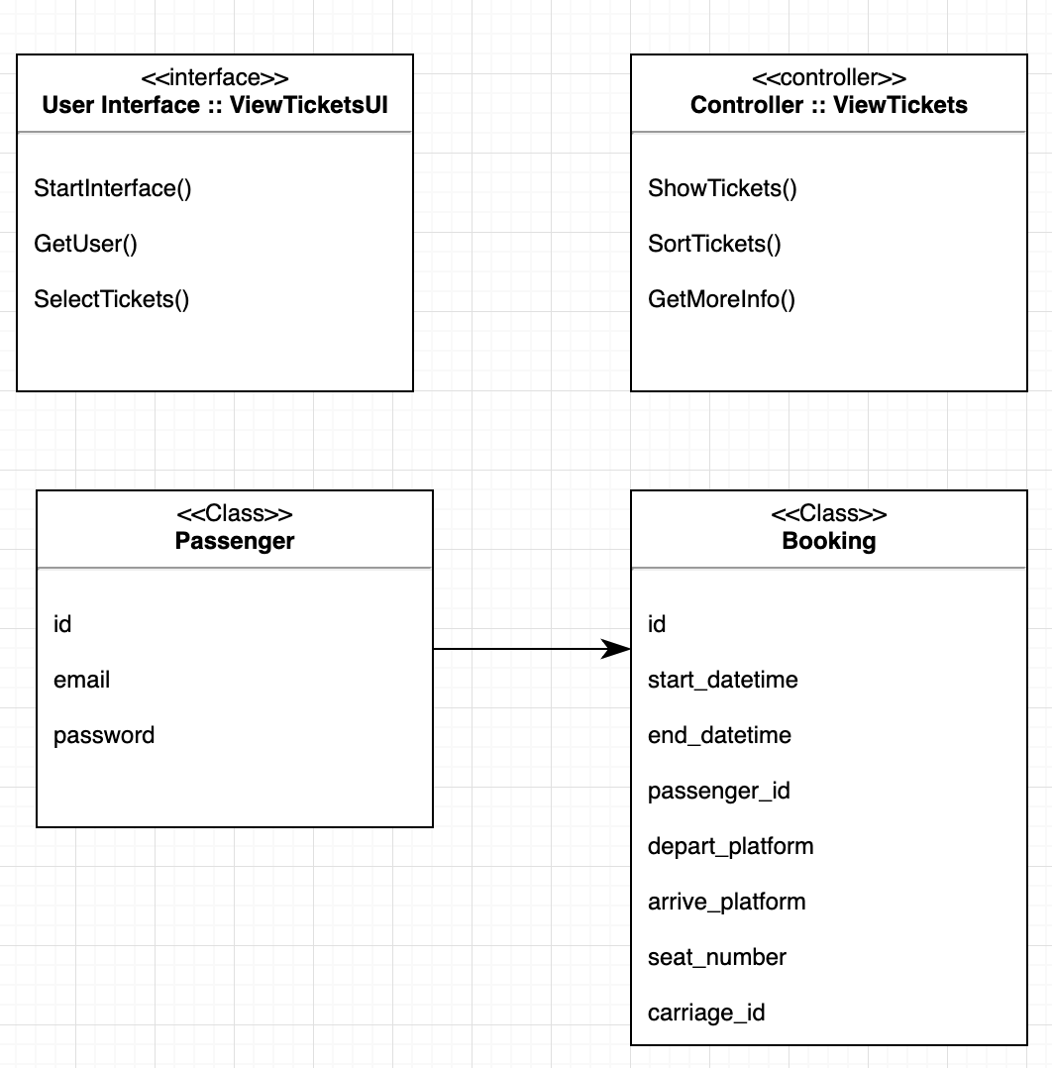

This user story was implemented as follows; when the application is opened the user is presented with a login form where the customer can enter their ConnectedRail email and password.

Due to time constraints the login for all applications in the system has been implemented in the same way, the API lacks a /login endpoint meaning that the mobile app will send a GET request to the /passengers endpoint and pull all passenger data down and then iterate over the JSON array until a match is found. Given more time, a /login POST endpoint could have been setup and the computation of returning the correct account according to the login details provided could have been offloaded onto the server, where it belongs. While iterating over the array, the application looks for a matching email and the SHA256 hashed (and custom salt) equivalent of the password provided. When this is found, the method returns that JSON object, switches to the logged in view and passes that object between the views by taking advantage of Xamarin “Extras” which are used to pass data between different views. When logged in, the application now has that passenger’s unique ID which can be used to fetch other relevant data about the passenger, for example their tickets; expired and currently active.

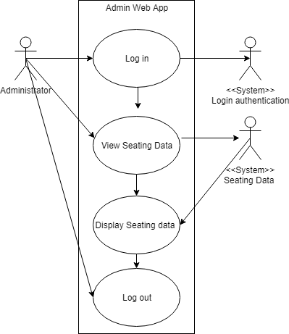

This use case depicts the interaction between the system and Administrator during the task of viewing seating data for a journey. The administrator logs into the system with the unique login, once in the Admin app the user can request to view Seating data, Once the data is displayed the user logs out.

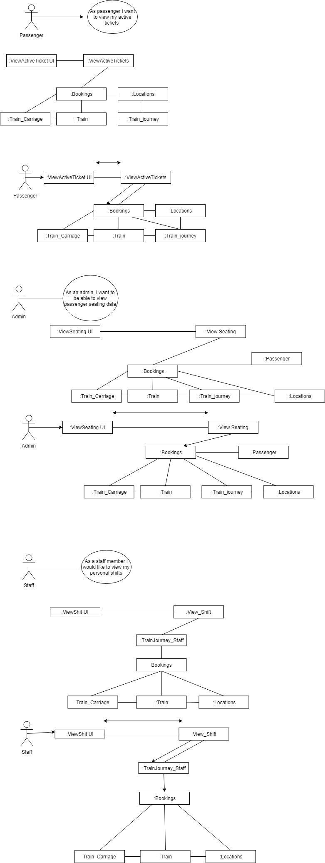



This user story was implemented as follows; the administrator has a page on their application entitled “seating” where they can view passenger accounts and also all bookings made by said passengers.

The UML diagram generated from the code written is the same as the UML generated for the mobile view tickets use-case. This is because the passenger viewing their tickets (their bookings) is the same as the admin viewing the passenger’s tickets (bookings) therefor the same general programming ideas were implemented.

Initially, when the page loads, a GET request is sent to the /bookings endpoint and they are displayed in a custom created HTML table. When the initial booking data has loaded, other GET requests are sent off to fetch other relevant data such as: where the booking entitles the user to travel from / to, what platform they are departing from / arriving at and at what times. These are then loaded into the HTML using data- attributes and are then constructed into a modal that the administrator can click to get a more comprehensive breakdown of the booking in question.

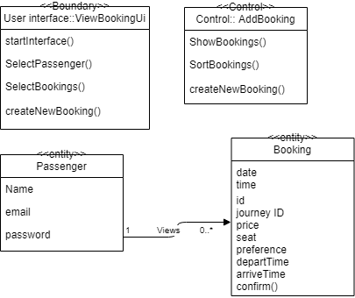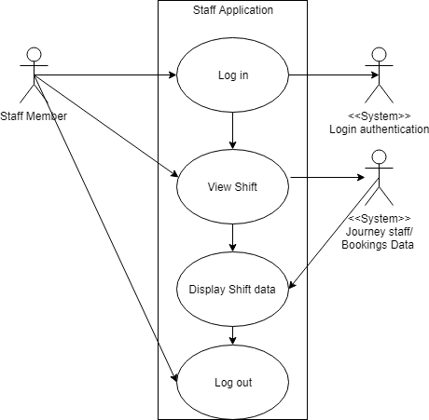

This Use case diagram shows a staff member checking what shifts they are working on, the system displays the requested information, after the information is displayed the user logs out. This was implemented in the staff application by a series of GET requests to the API, one was to TRAIN_JOURNEY_STAFF to get the shift ID and the journey ID, from this the journey id was used for a GET request to TRAIN_JOURNEY/id to get the location IDs. The location IDs were used to get the location name with a GET request to LOCATIONS/id. This was all displayed in a table with a popup modal for additional information on the shift.

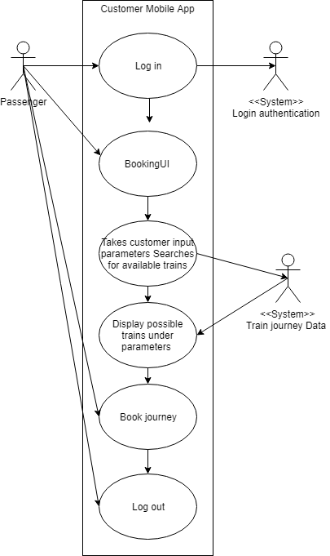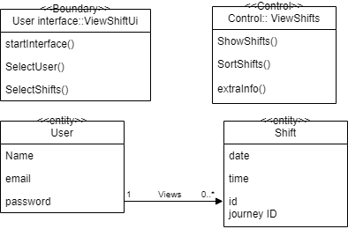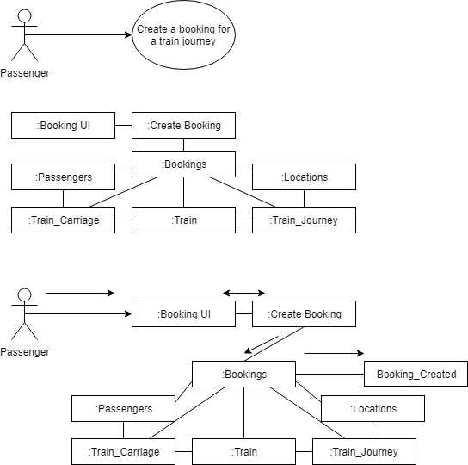

This use case diagram depicts a passenger/customer using the mobile application to create a booking for a journey. Firstly, the user must be displayed with a page in which they are able to choose the set parameters to search for the exact train journey they want. Once the parameters are put in the user submits the page and the system will display the relevant information. The passenger then books the journey and then logs out once the transaction is complete. This was implemented on the mobile application uses a series of GET requests to get all the necessary booking information. A POST request will be used to add a new booking.

## How did the design change during development?

The design for ConnectedRail stayed close to the initial concepts during development, adhering to a simplistic form which seemed consistent throughout use of all the applications. Consistency was achieved amongst applications by using similar design features such as colour scheme and use of modals and popups to display information to a user when requested. This was a preferred method for presenting data to an end user as they would not have to redirect to other pages for different functionality, staying rooted in a well-designed main page would be easier for a user to learn and understand the system. This was replicated within the Java application by using Jframes and Jpanels, the panels are on a frame and the pop ups appear on top of the panel.

Initially the project had no branding, but after a meeting part way through development the brand name ConnectedRail was agreed on, directly after the meeting a group member Reece designed a logo for the project, both branding features were implemented amongst the applications for consistency.

# Database Design

## Database diagram (ERD):

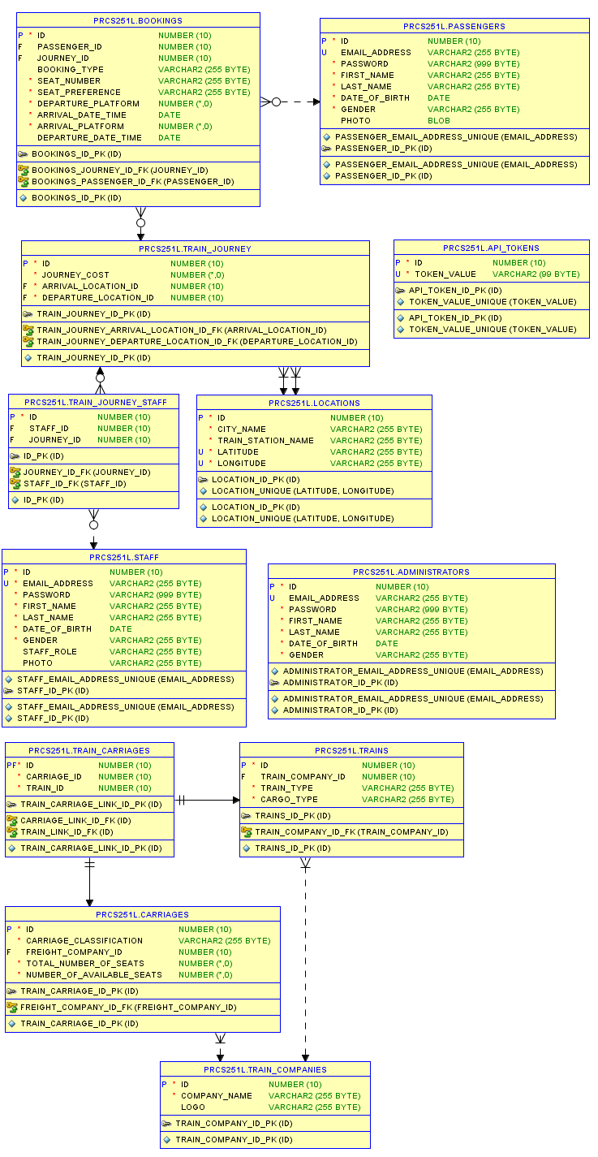



## 

## 

## 

## Create statements (tables, triggers & sequences) with descriptions:

Here is the create table statement and sequence for the table ADMINISTRATORS. This statement includes REGEX for the email address. This table also has a date of birth trigger, to ensure that an admin is above 18 years old.

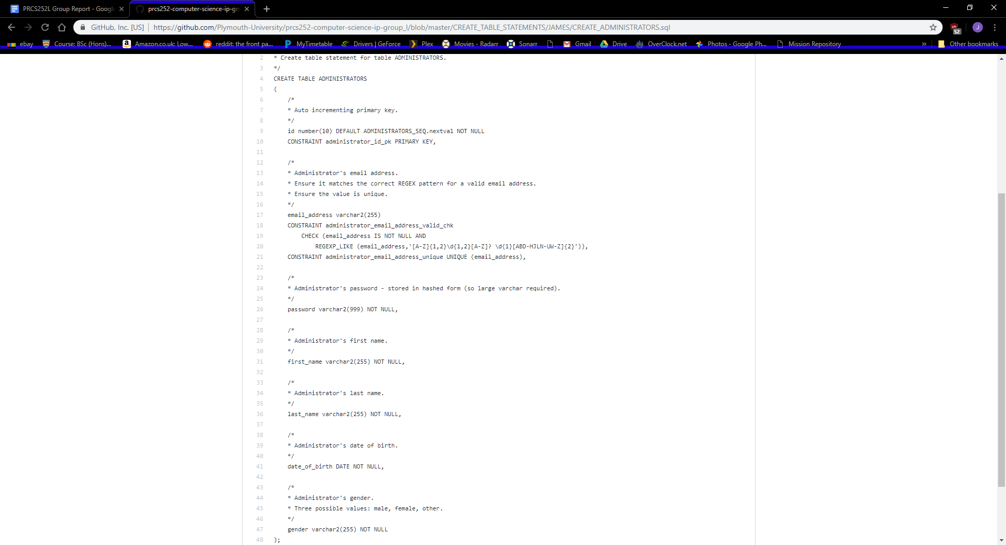

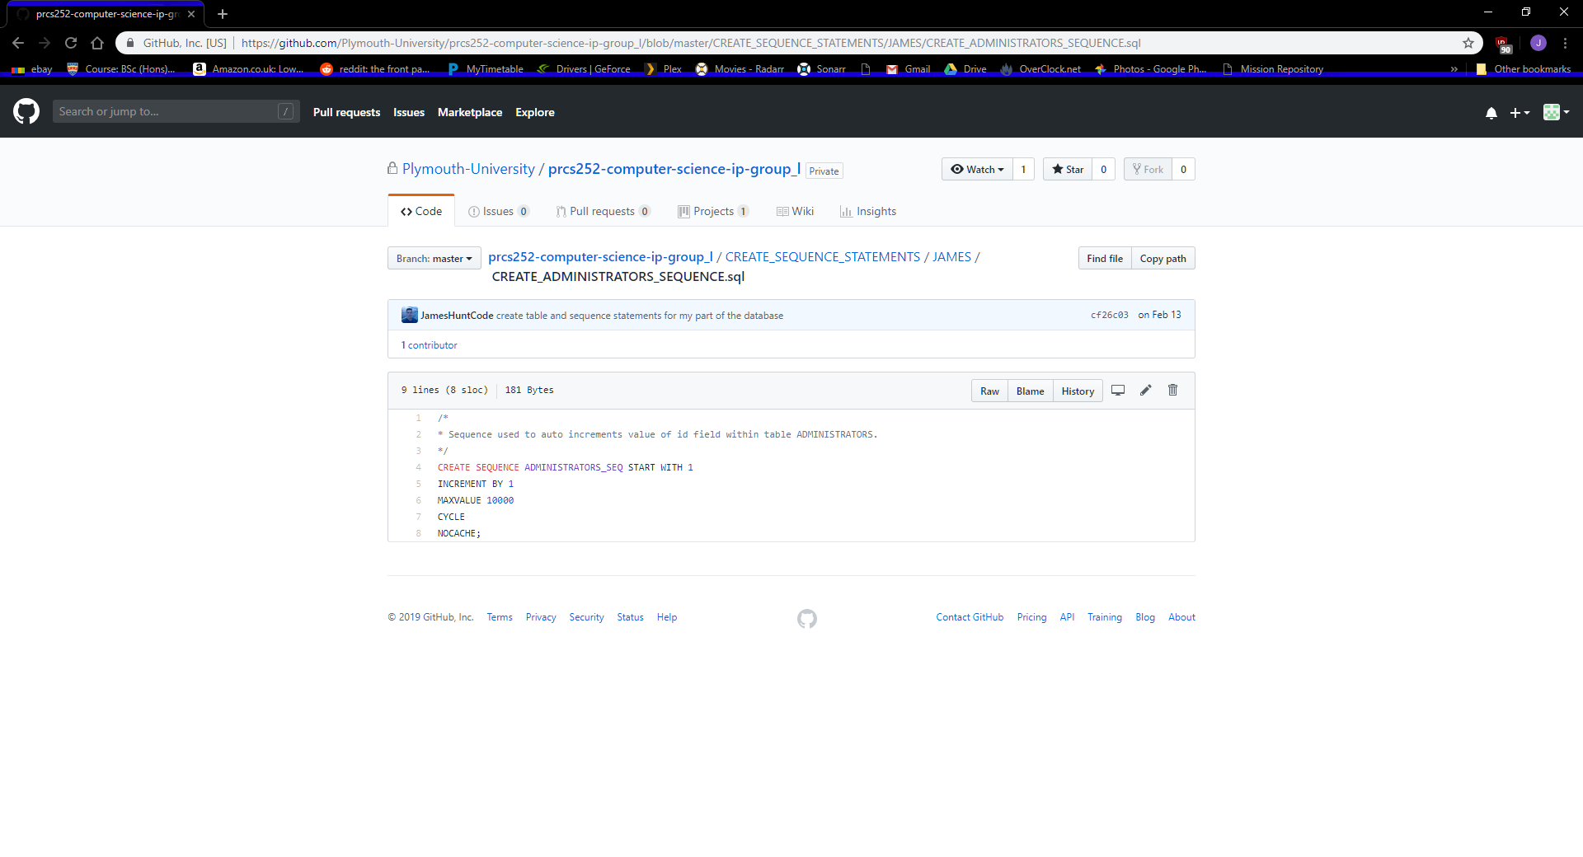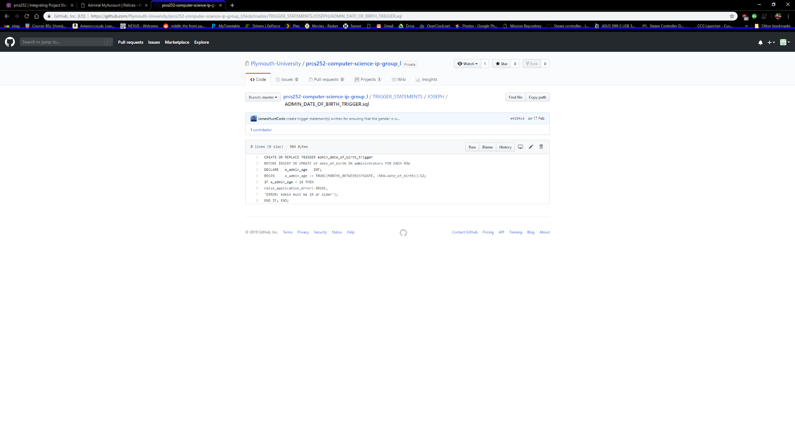

Here is the create table statement and sequence for the table API_TOKENS.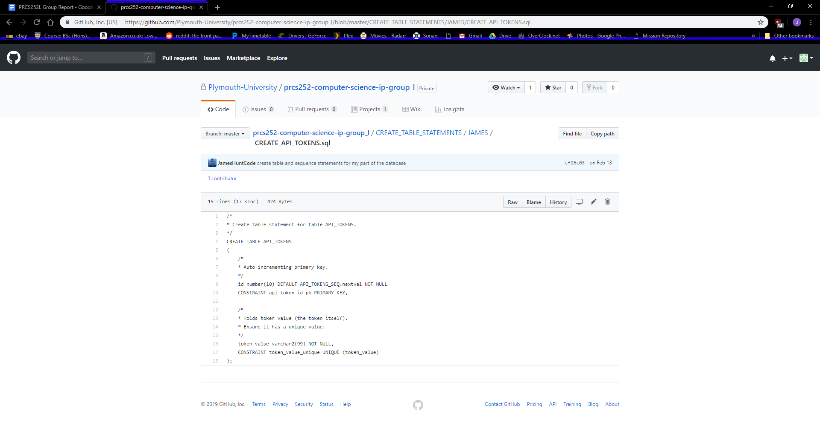

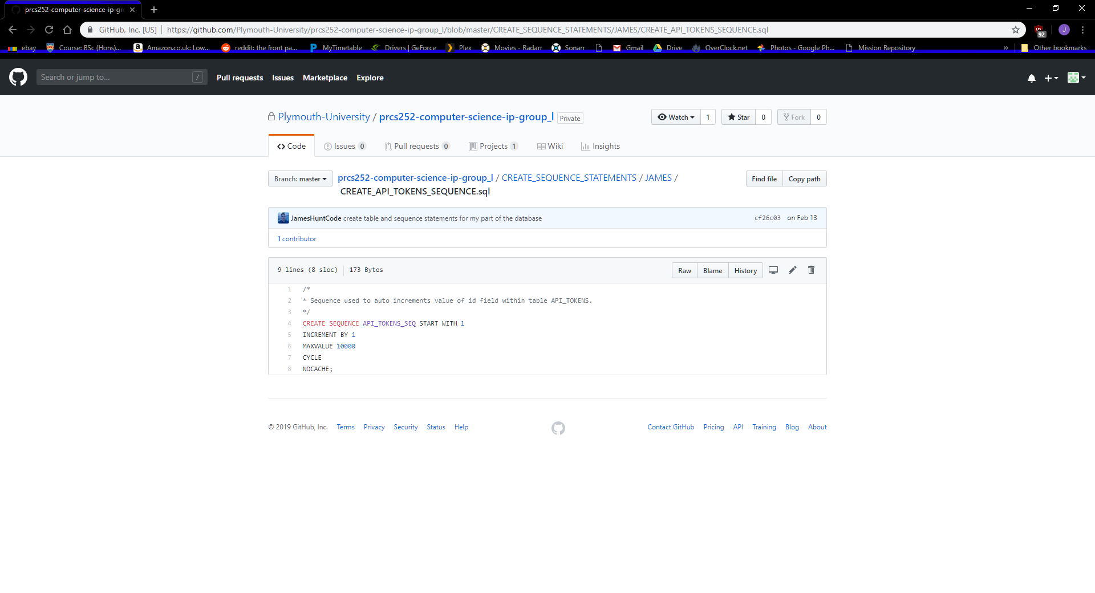

Here is the create table statement and sequence for the table LOCATIONS.

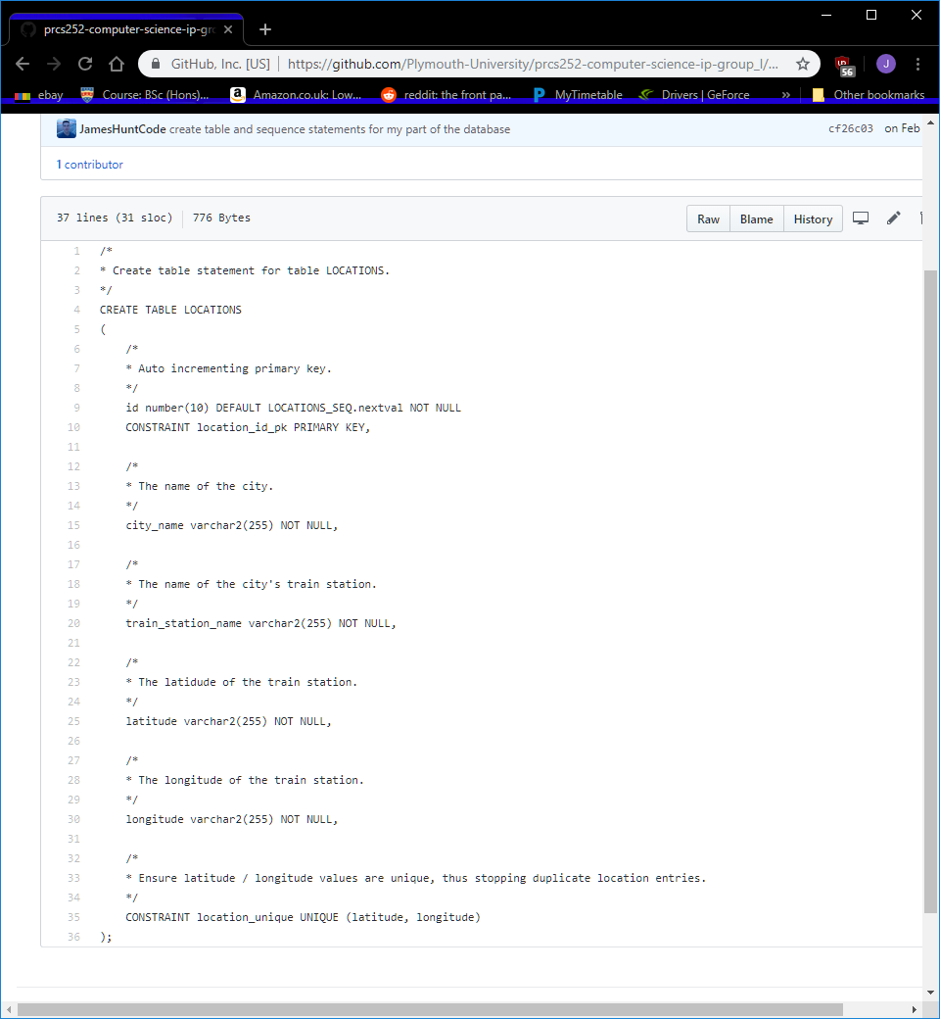

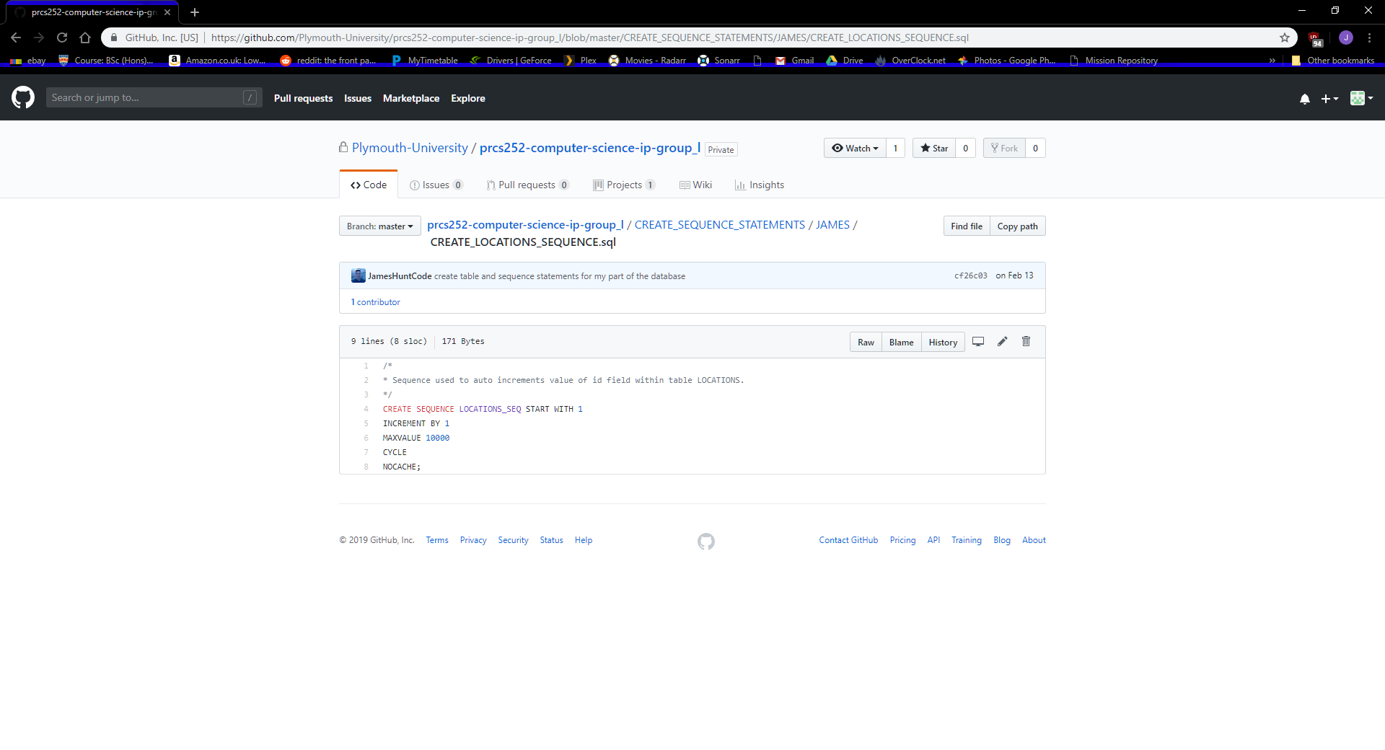

Here is the create table statement and sequence for the table PASSENGERS. This statement includes REGEX for the email address. This table also has a trigger to ensure that passengers that are making a booking are over 16 years old.

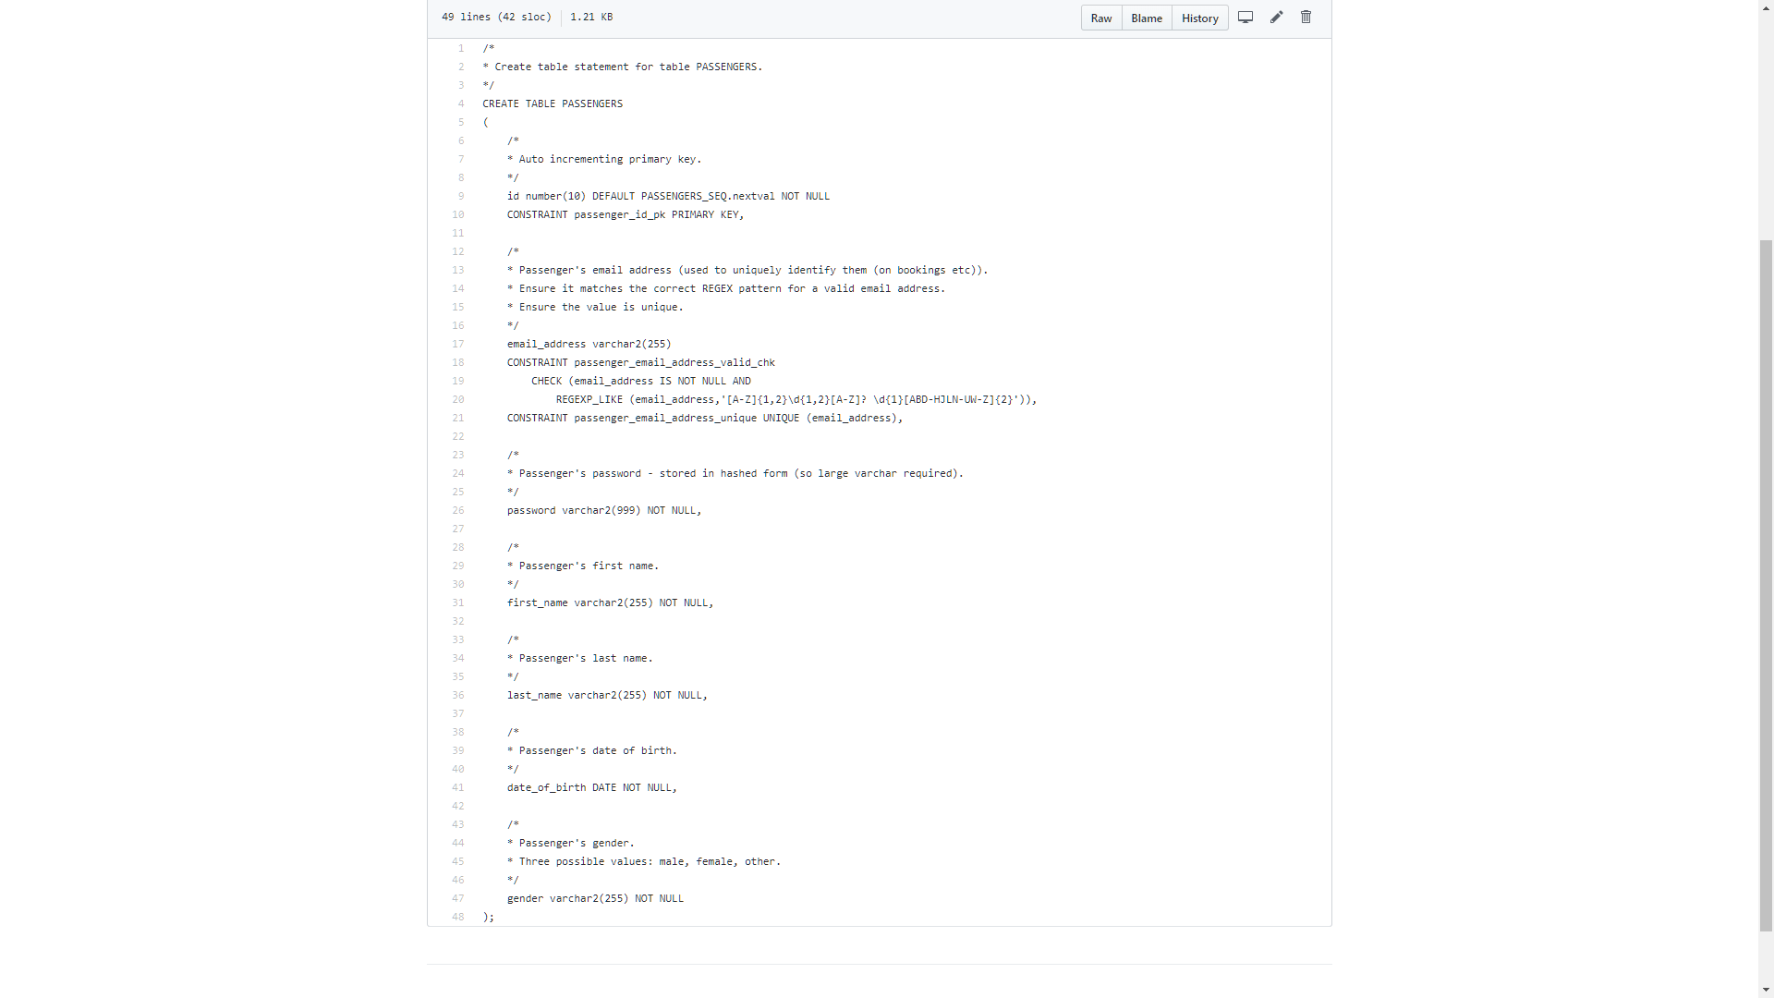

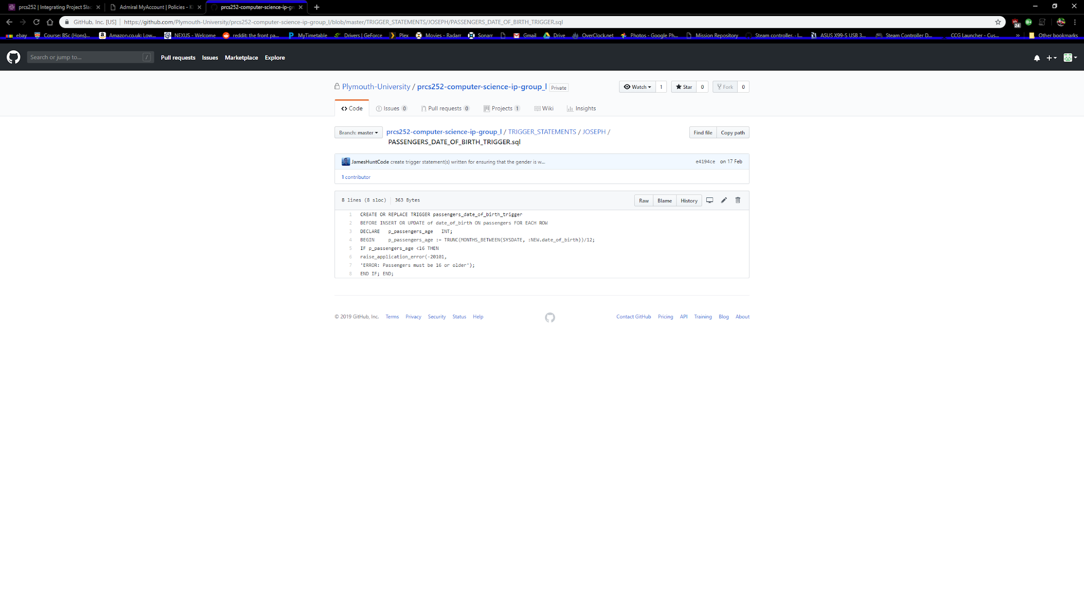

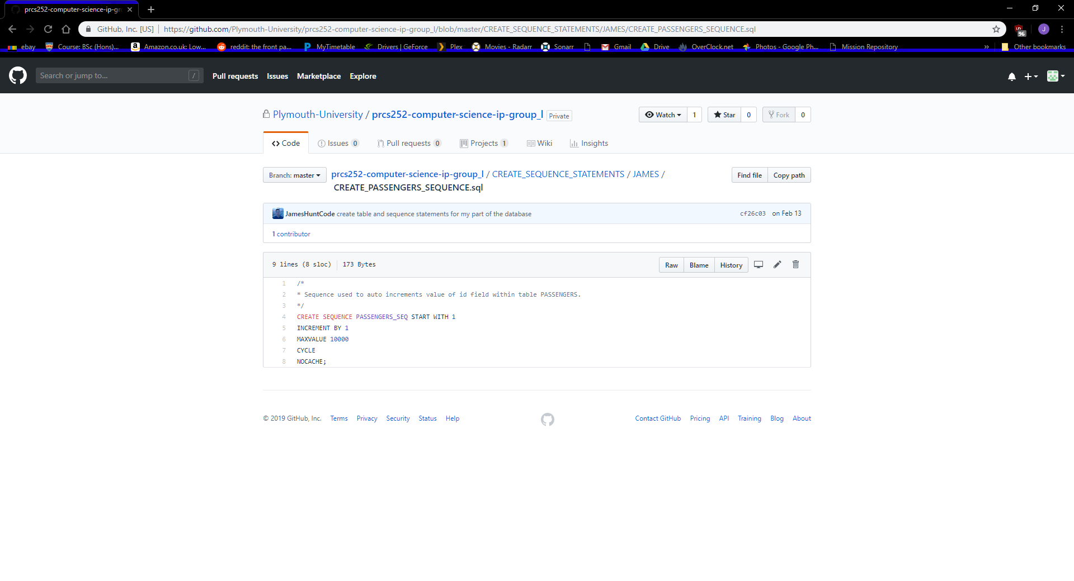

Here is the create table statement and sequence for the table STAFF. This statement includes REGEX for the email address. This table saw many updates during development, with an additional staff photo column being added then phased out due to API clashes. This table also has a trigger to ensure that staff are over the age of 18.

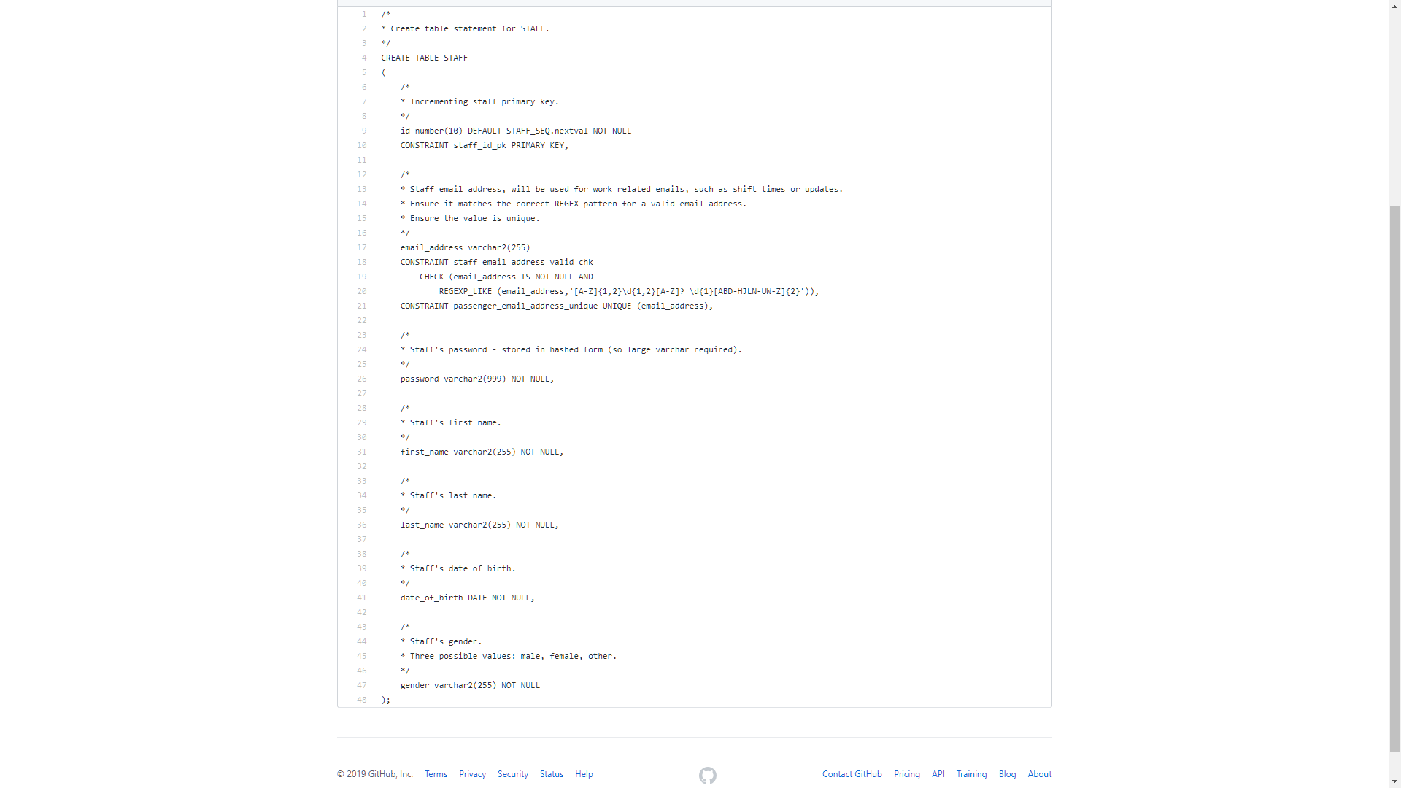

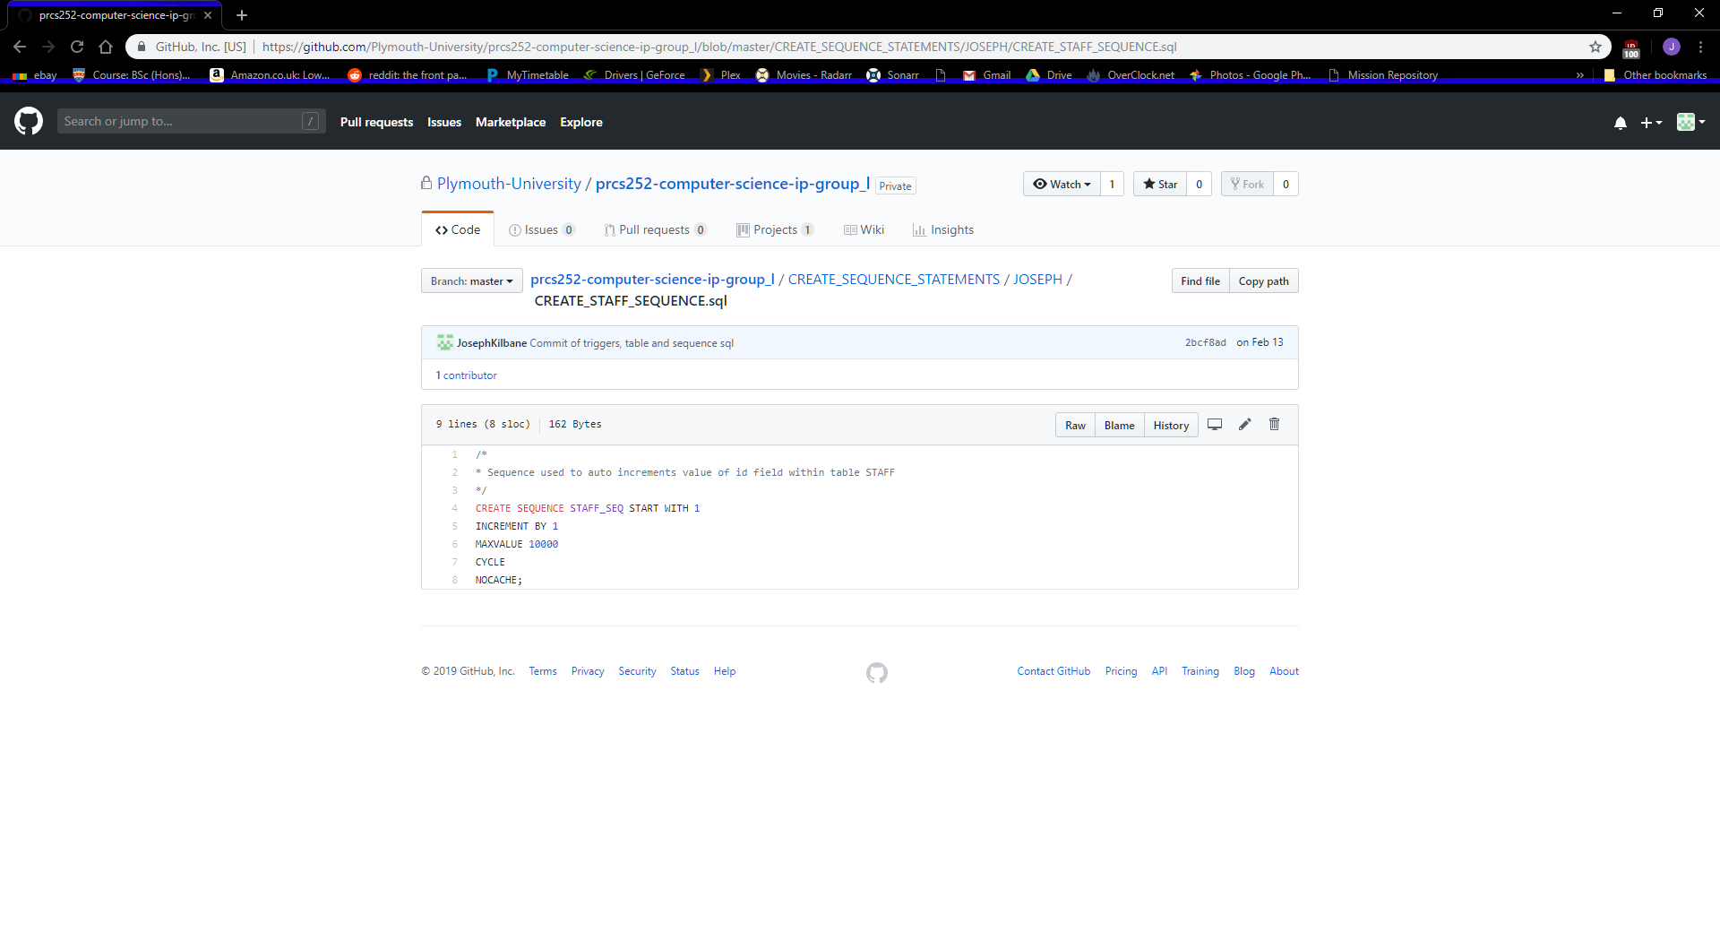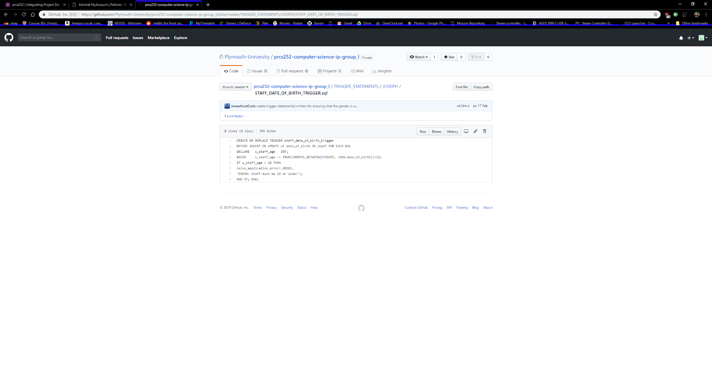

Here is the create table statement and sequence for the table TRAINS.

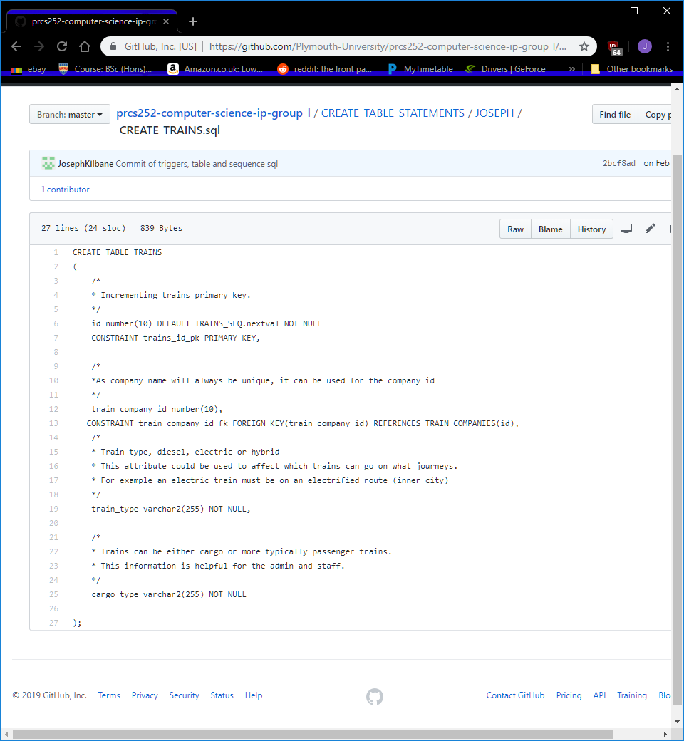

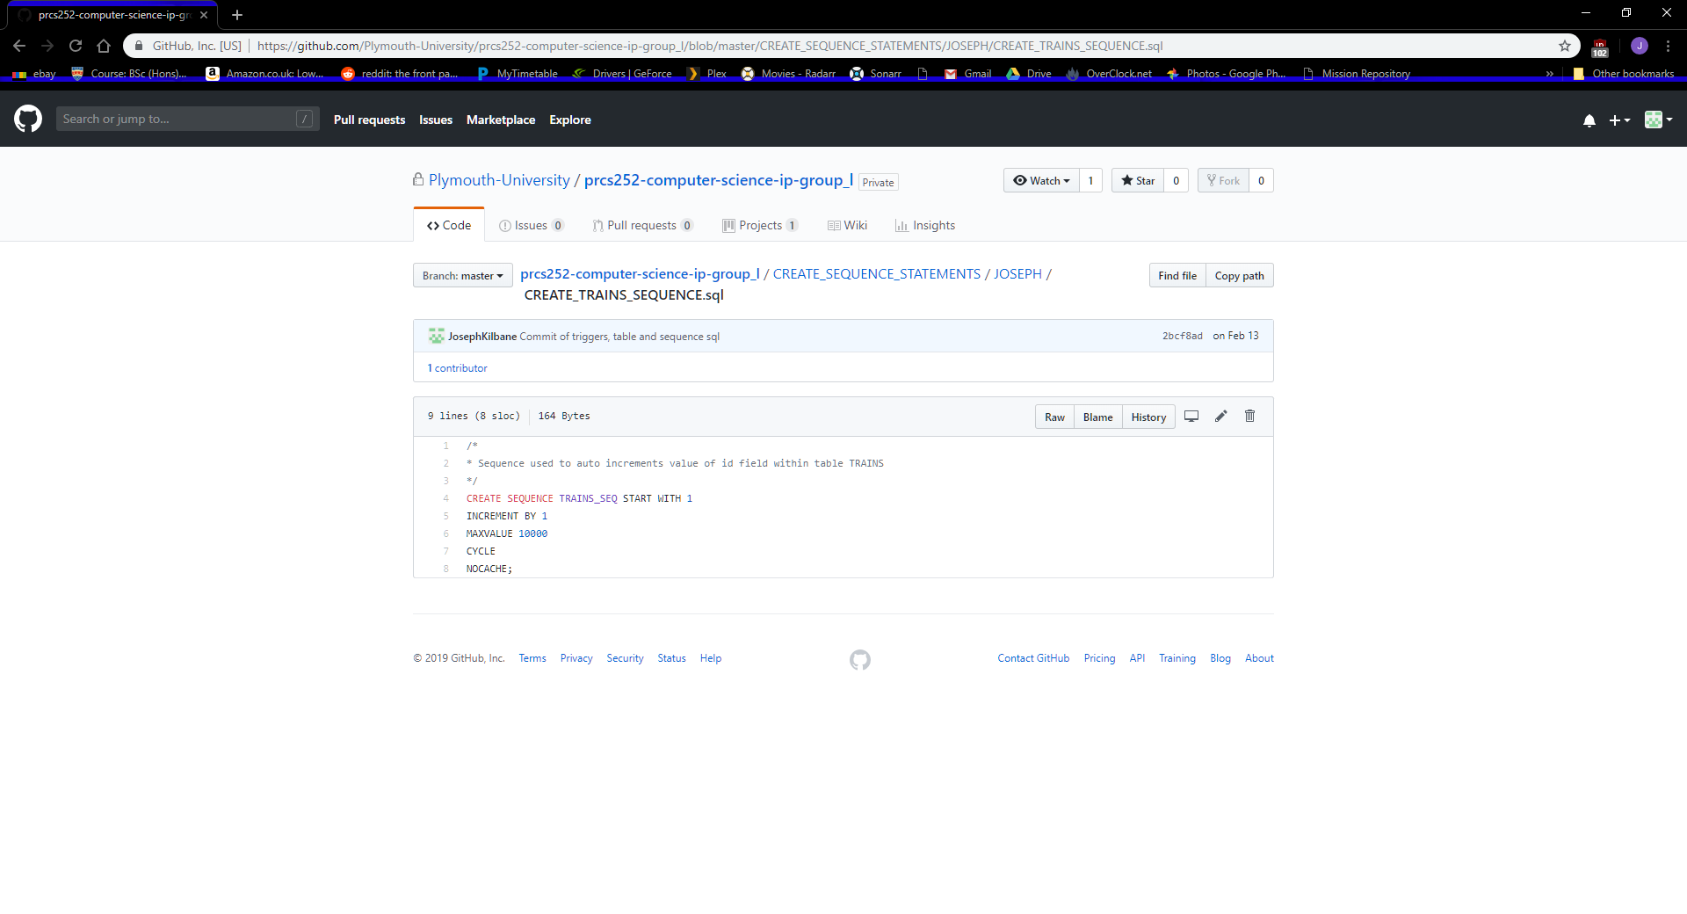

Here is the create table statement and sequence for the table TRAIN_JOURNEY_STAFF.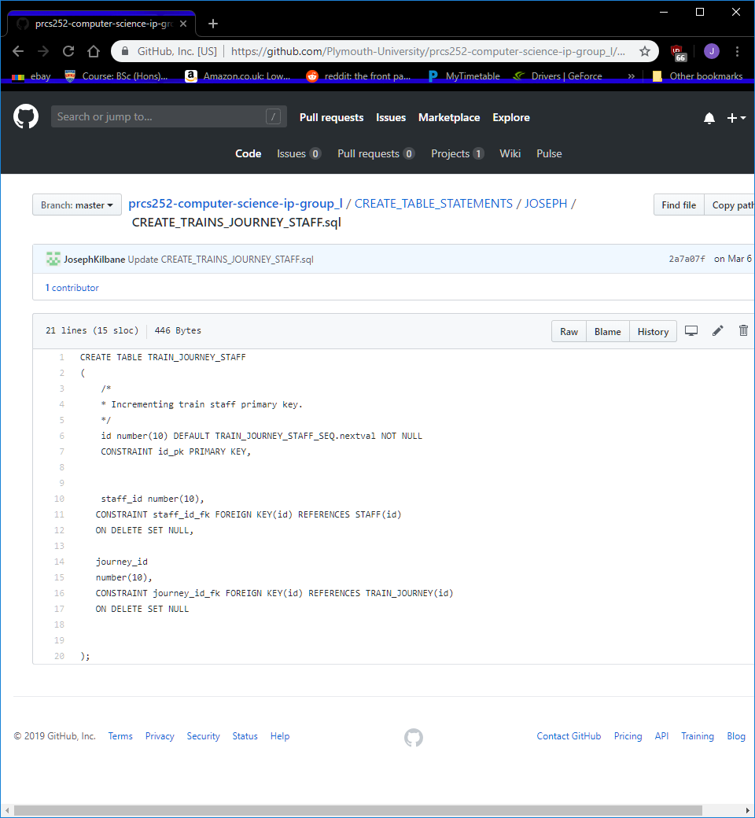

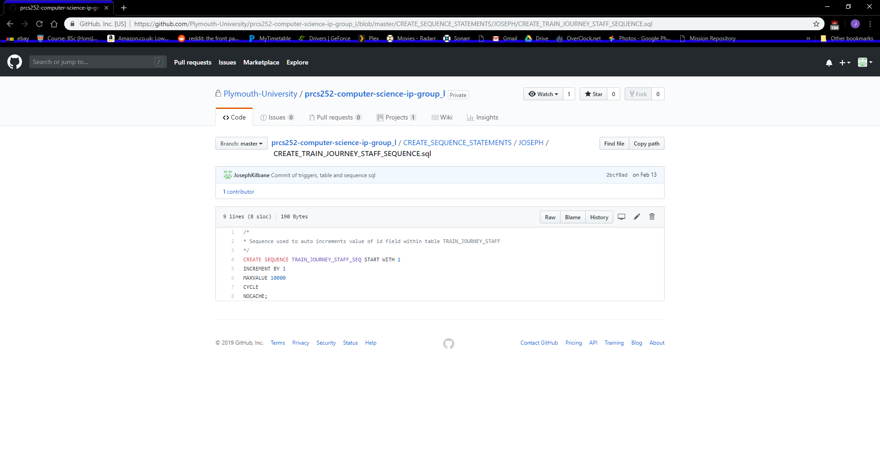

Here is the create table statement and sequence for the table TRAIN_JOURNEY.

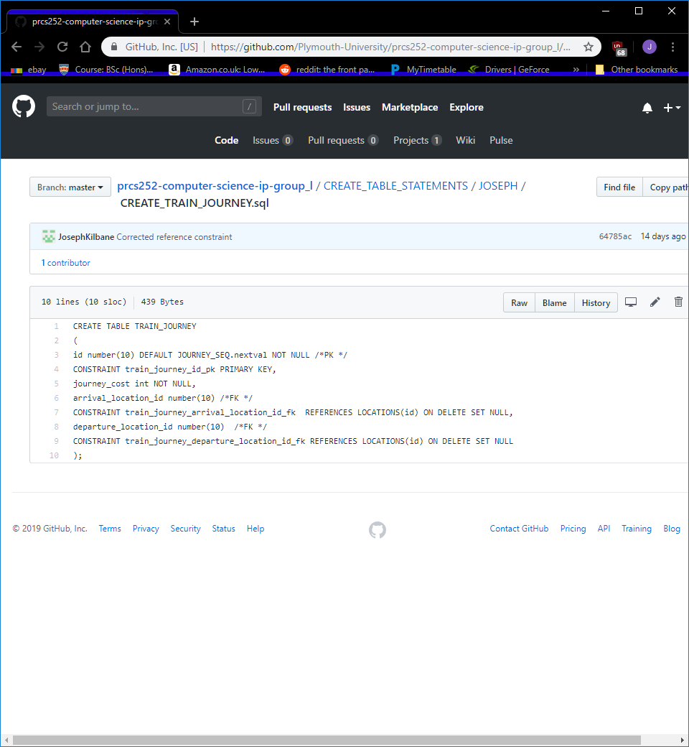

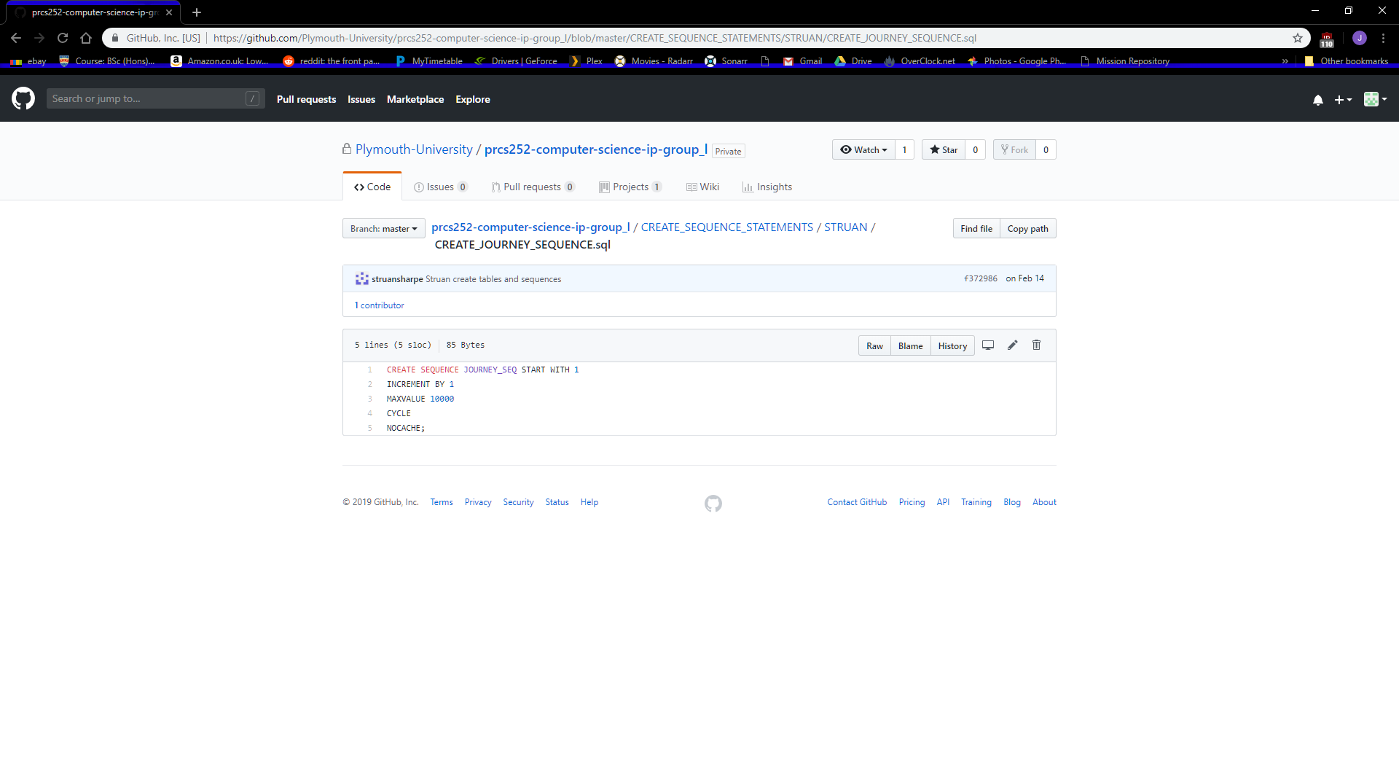

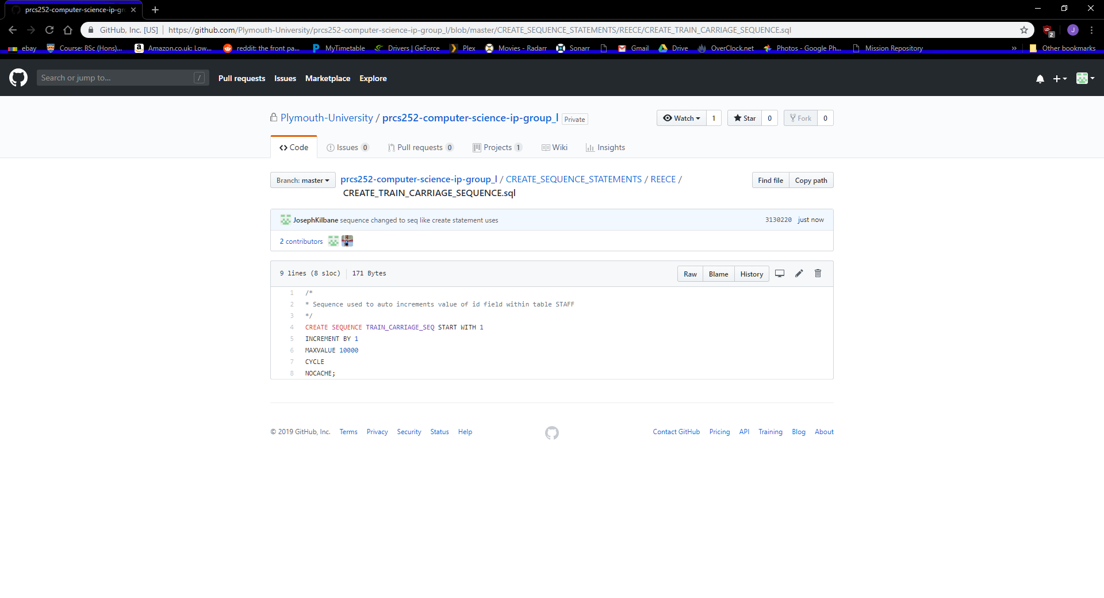Here is the create table statement and sequence for the table TRAIN_CARRIAGES.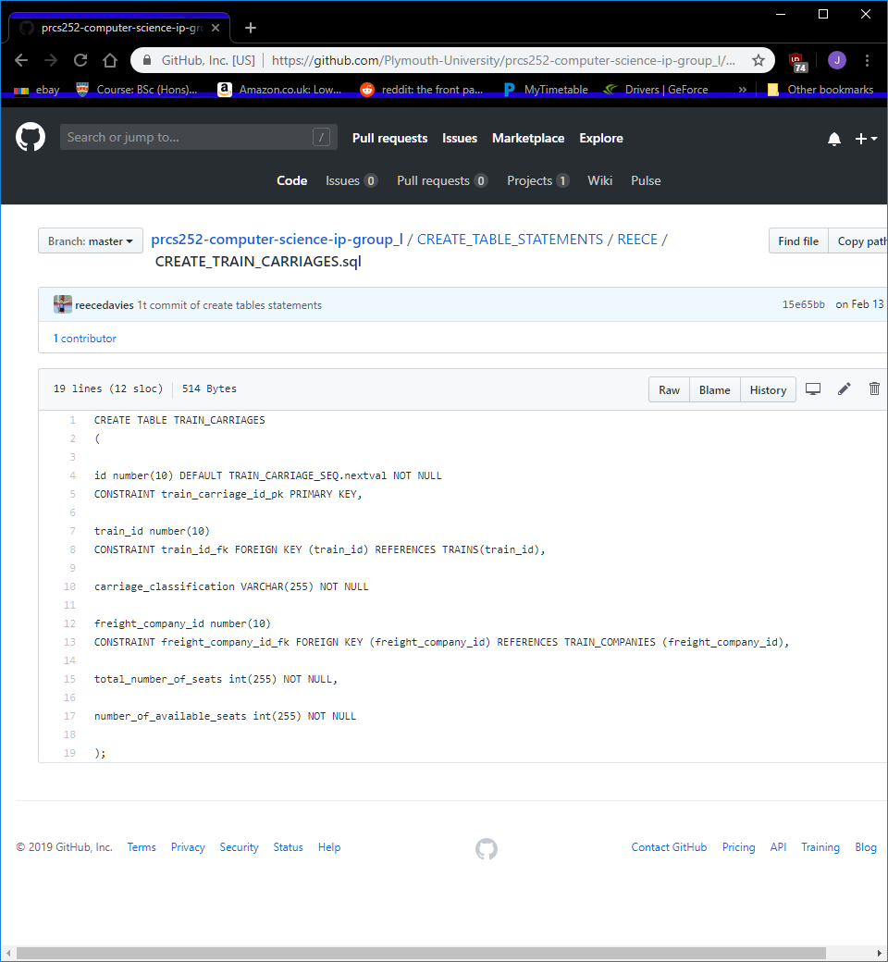

Here is the create table statement and sequence for the table TRAIN_COMPANIES.

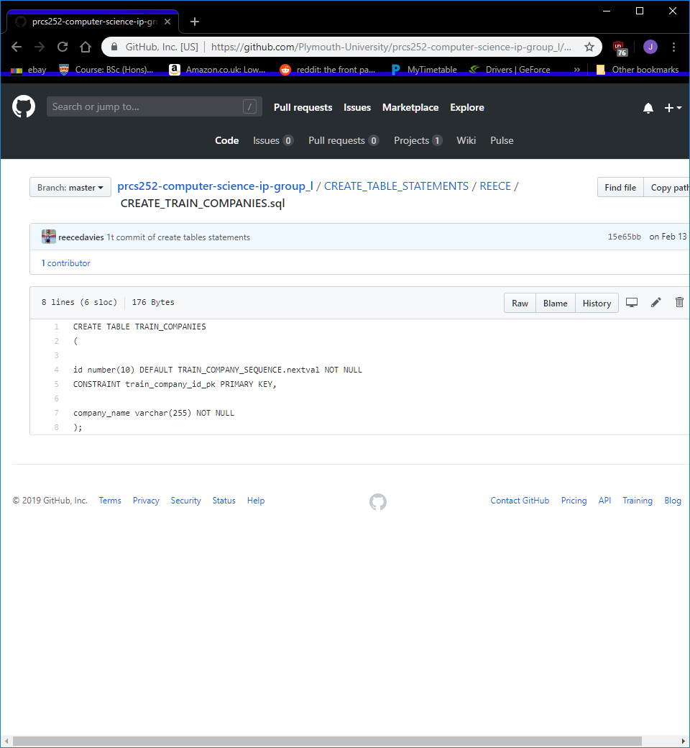

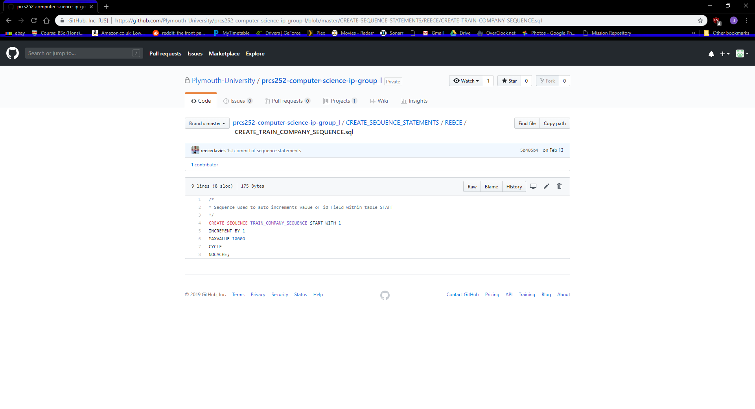

Here is the create table statement and sequence for the table BOOKINGS.

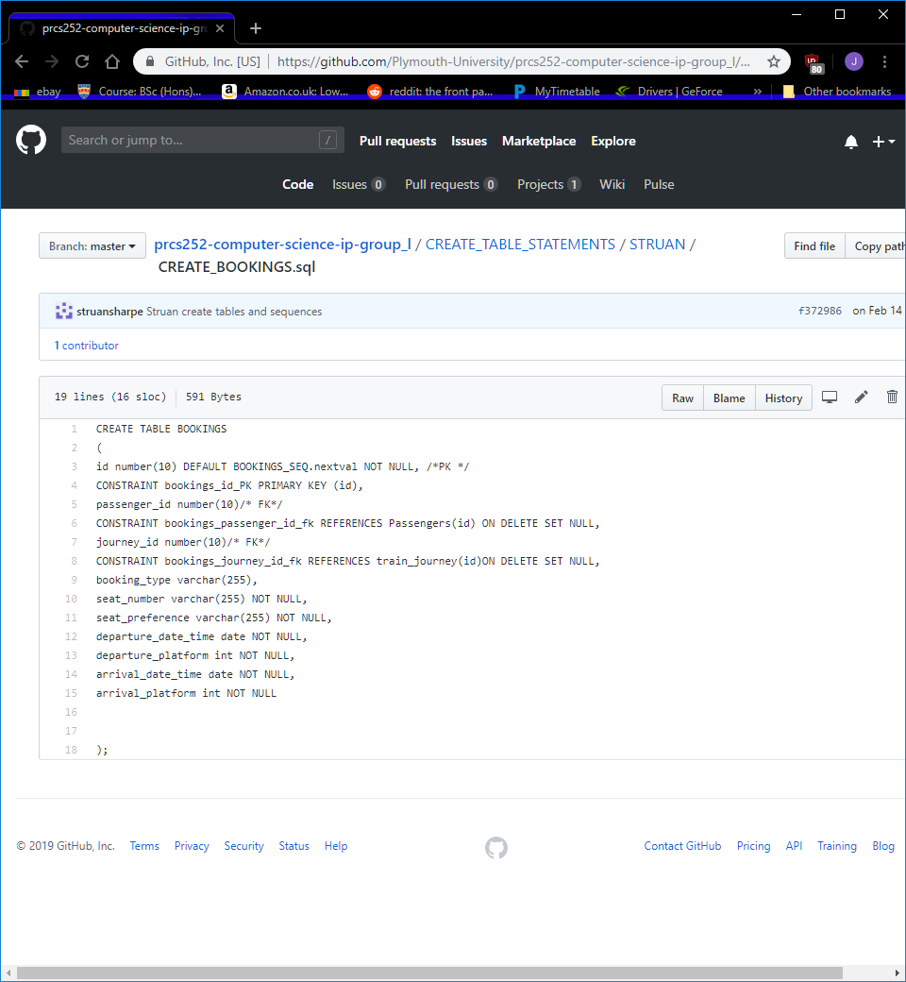

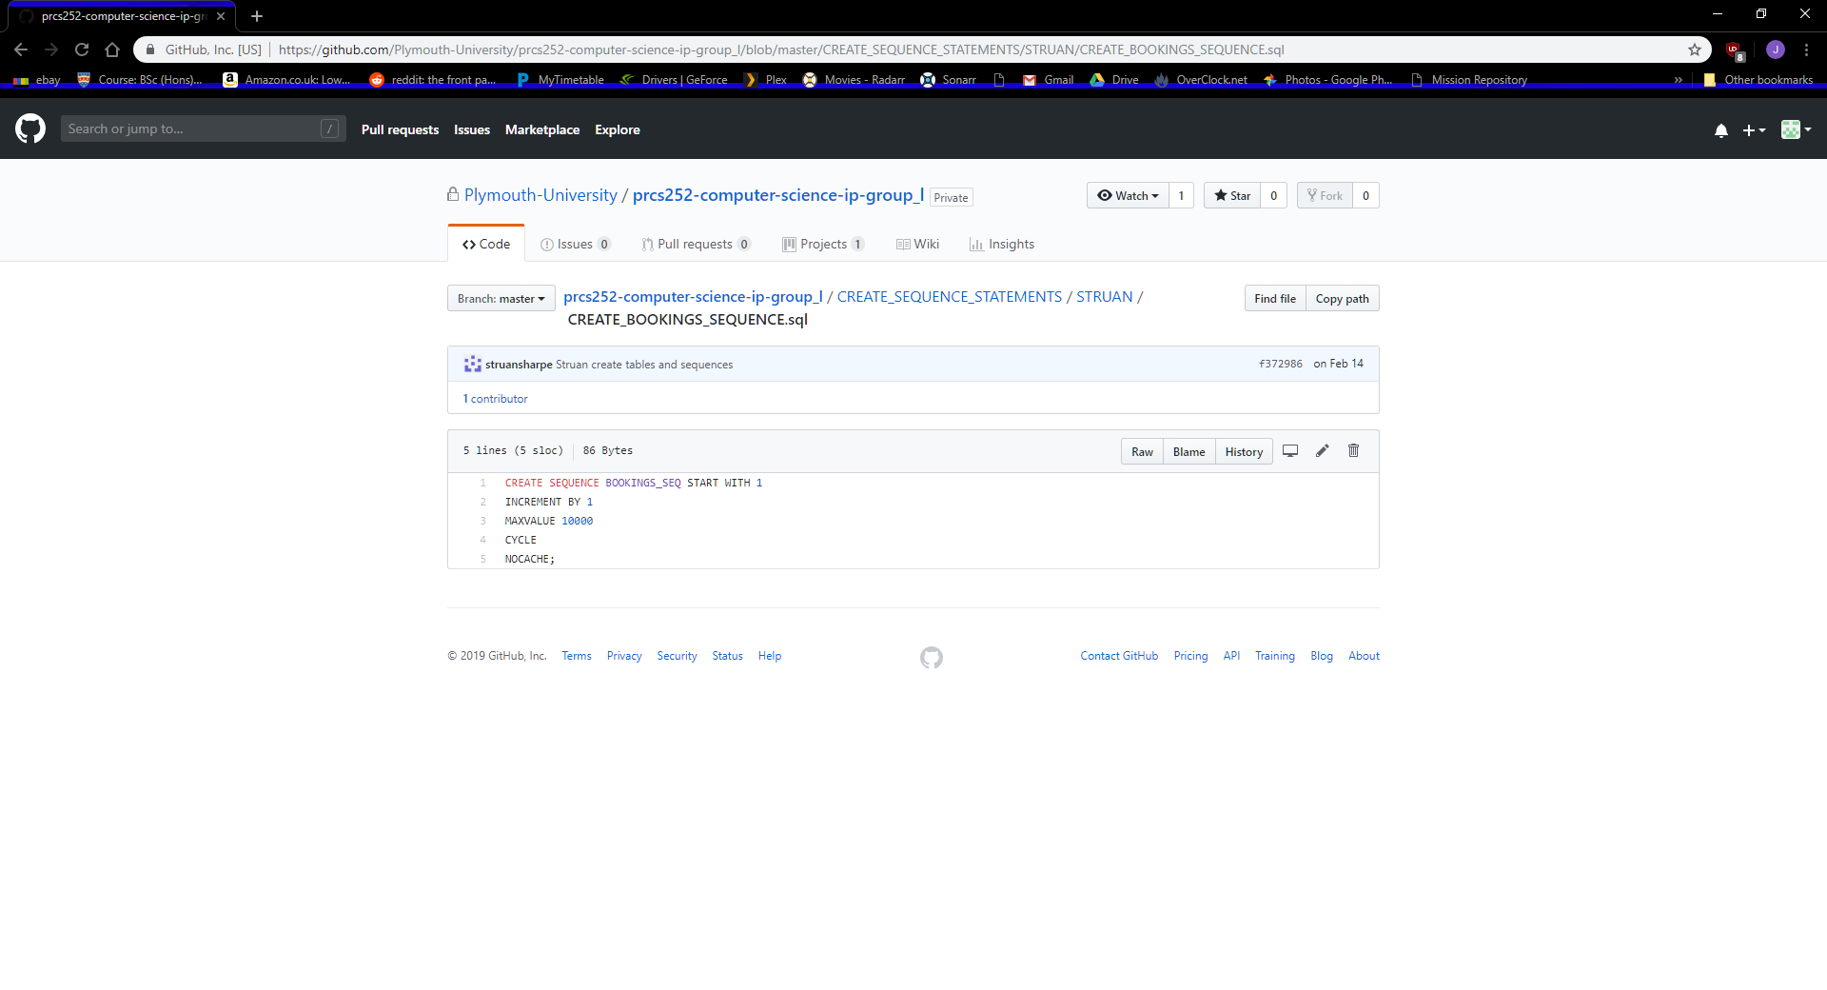

The below triggers were either work in progress or in the case of the gender trigger, causing an issue we could not solve.

This trigger is a work in progress, it was designed to ensure that two trains were not at the same platform at the same time.

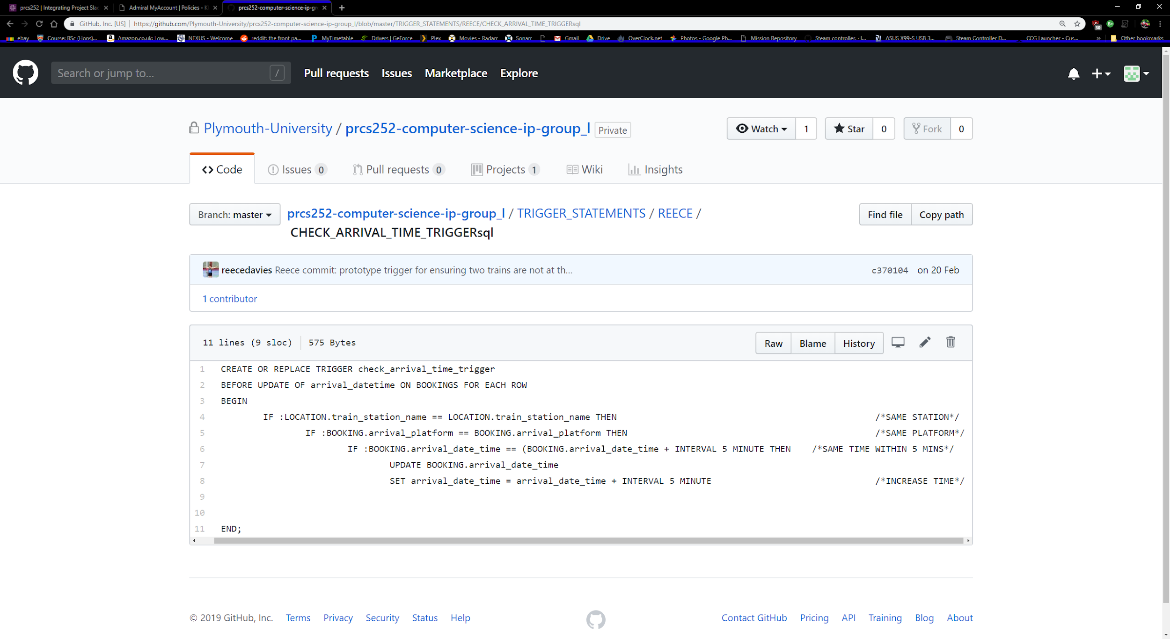

The below triggers originally were in the database, however for an unseen reason they were causing an issue with the inserting of data.

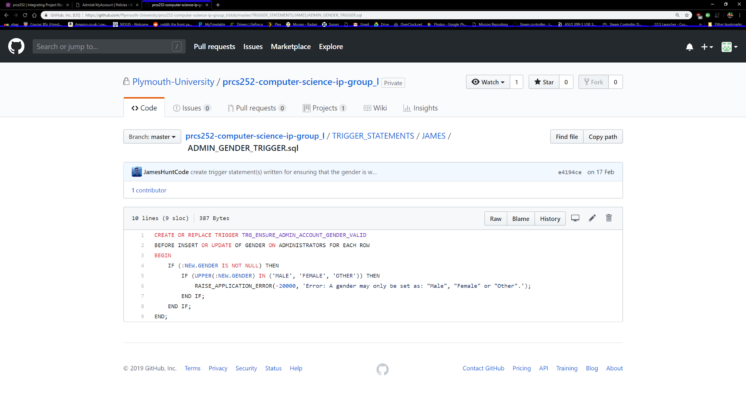

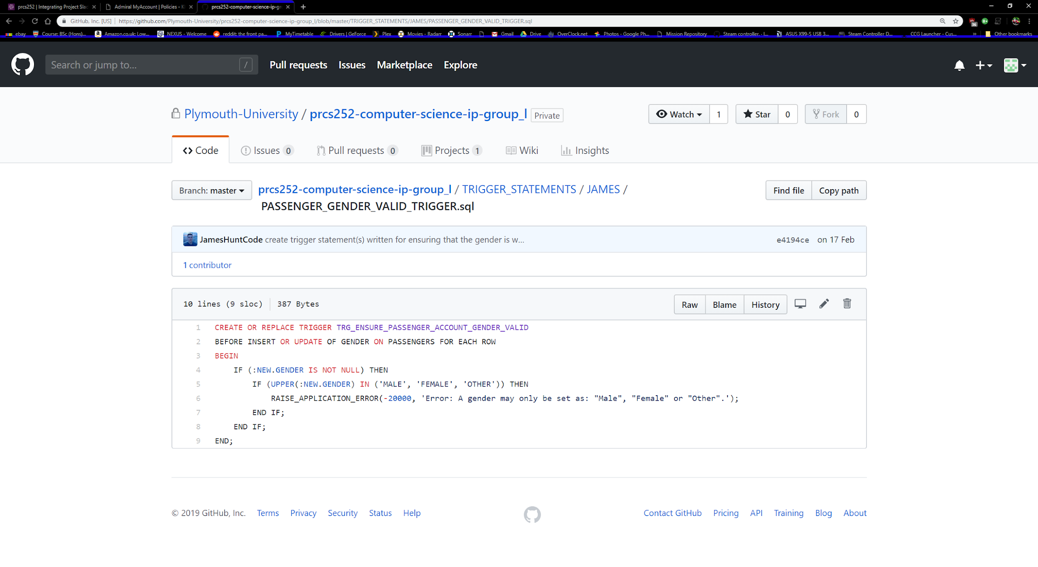

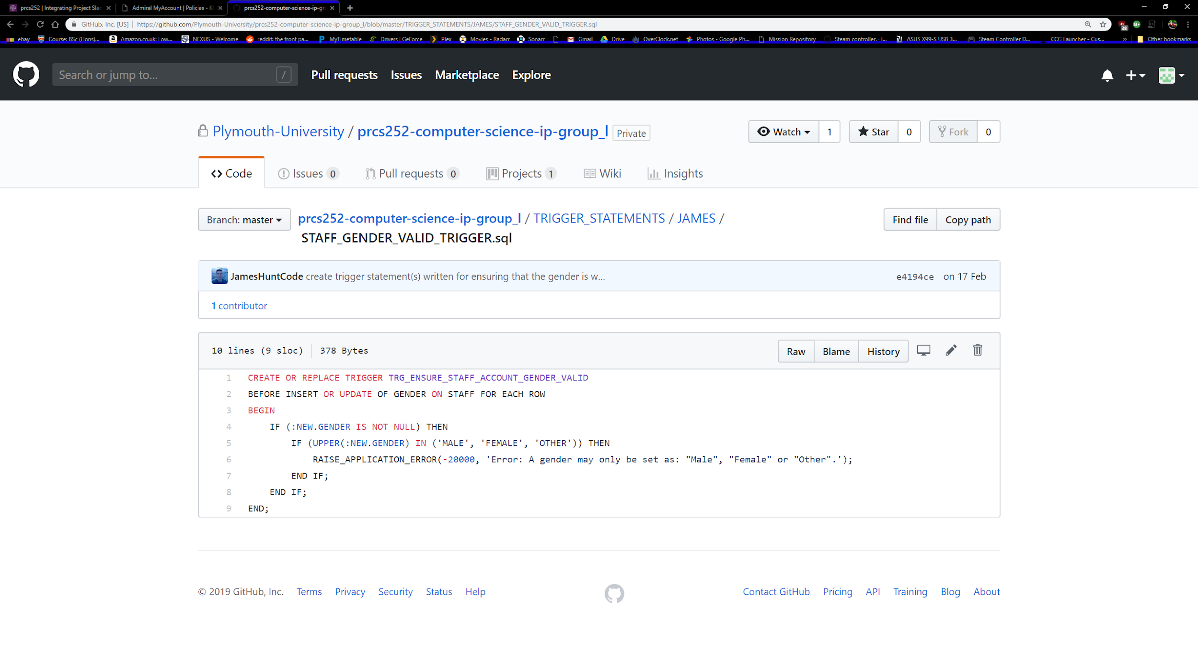

## 

## 

## 

## 

## 

## 

## 

## How does the normalised data and schema compare with the class diagram?

Below is the final version of the normalized tables before they were put into use. Once in use there were a few changes which shall be explained.

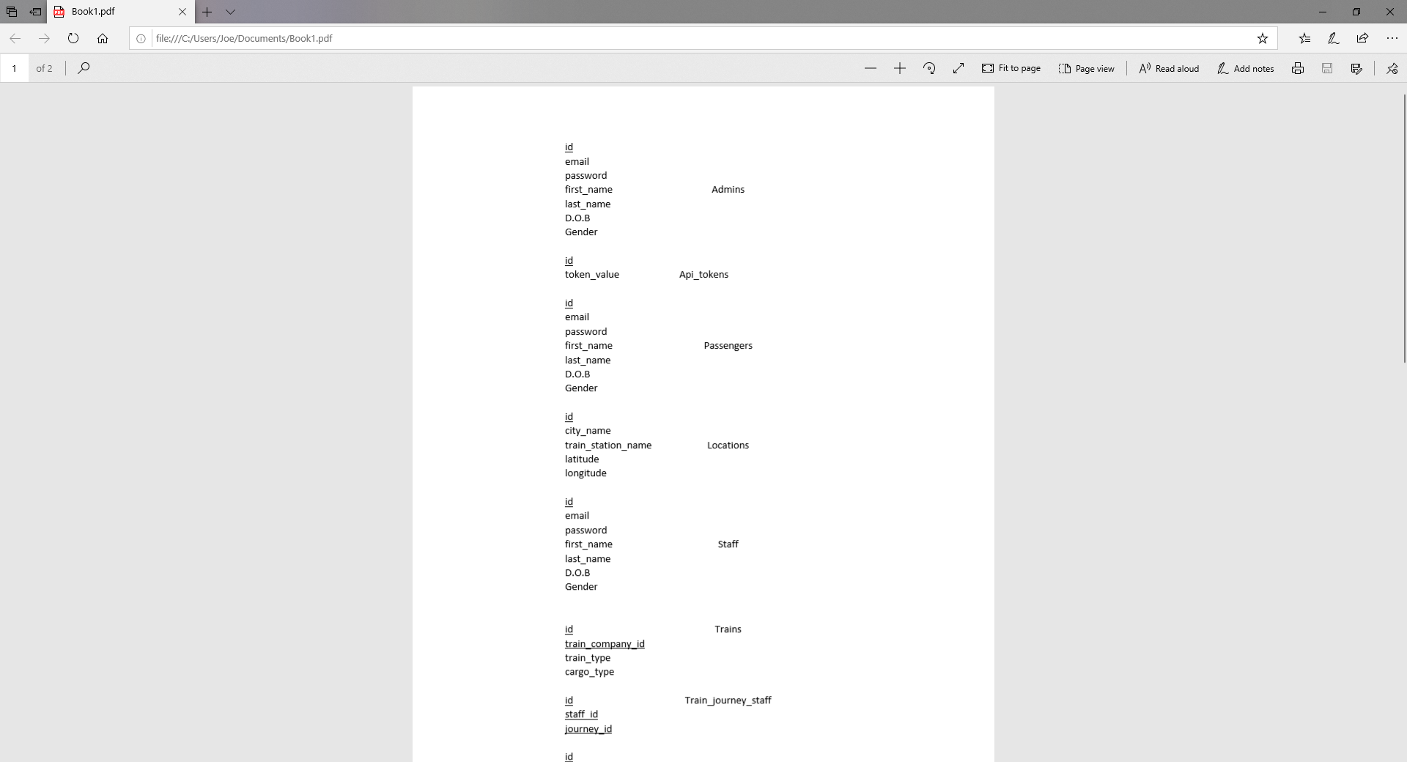

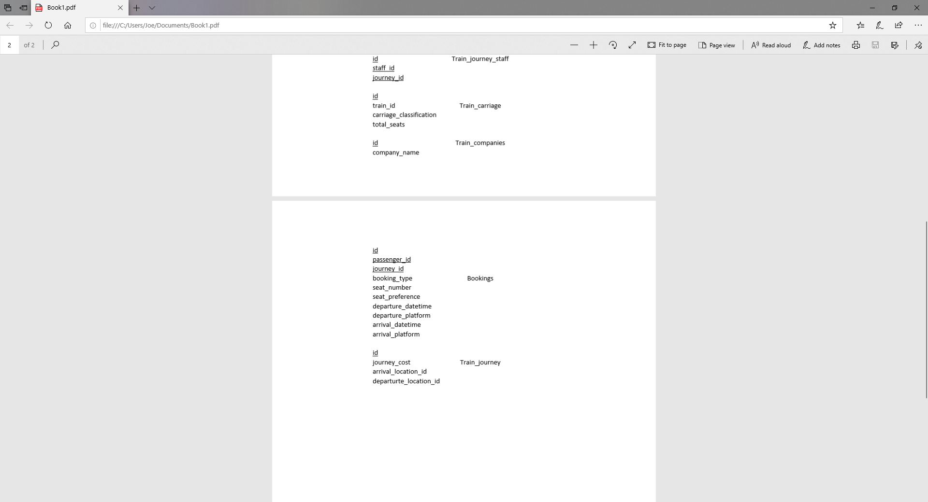

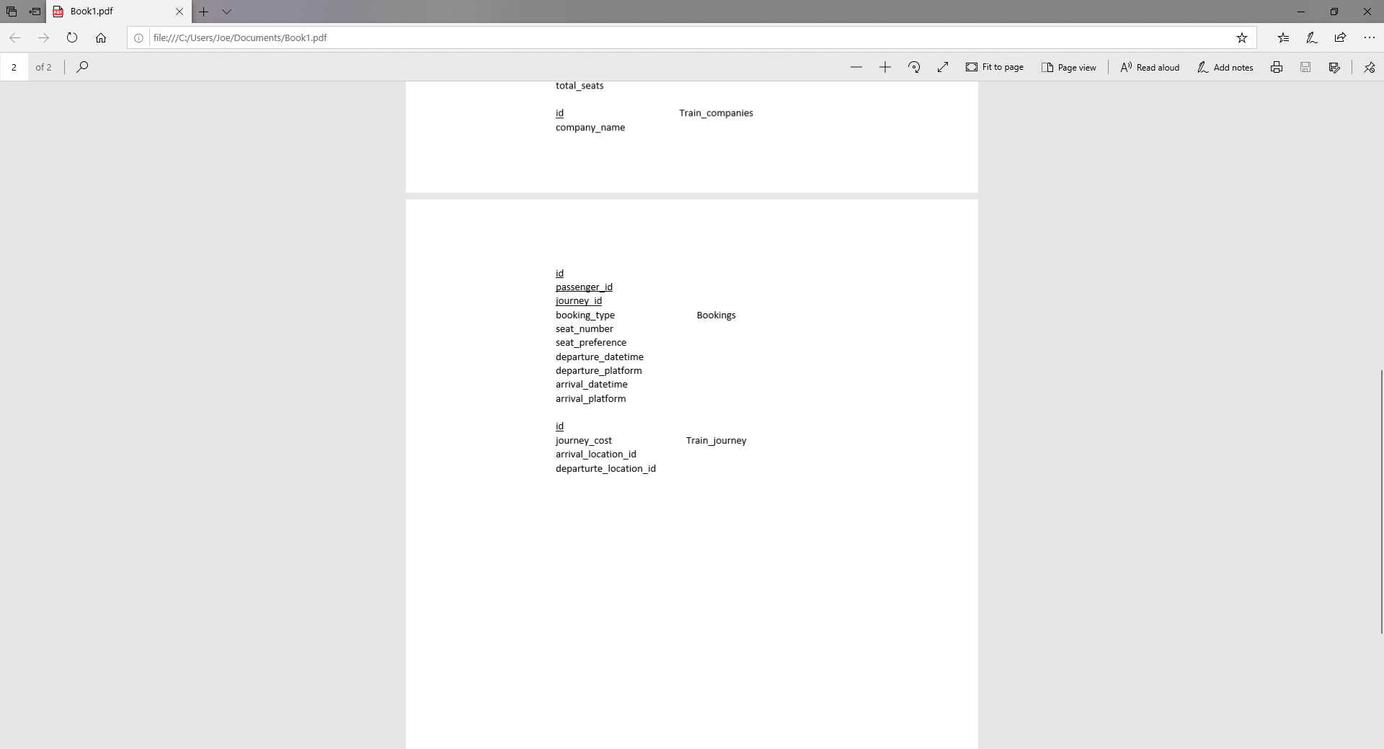

Overall, the tables stayed largely the same, with the addition of a staff role field and a photo field for all the users as well as the train companies.

The main change was the addition of an extra table called train_carriages. This was found to be needed in the development of the API, as it there was no way to link some of the tables together.

# Usability (feedback from testing)

## Progressive list (most important first) of required changes (by application):

* **Web application:**

During development of ConnectedRail, multiple outside sources were consulted regarding the usability aspect of the system. Initially, Dr. David Walker from the University of Plymouth provided some general feedback on the web application. A few changes were suggested, including:

* Space content out more (padding between subsections).
* Remove search popup modal.

These changes were taken on board and both were addressed in future commits, the padding between sections was increased by *10px* and the search modal was removed.

Later on in the project, another usability study for the ConnectedRail web application was carried out. The participant in this study was asked to complete several tasks and their response to the task at hand was examined and comments were recorded. The main comments made for improvements were as follows:

* Fly to location on map when clicked.
* Add a remove icon everywhere in the application.
* Customisable theme.

The above changes (after collected) were discussed as a team and they were prioritised into the list above (top is most important).

Rather than allow the user to simply click an icon, the extra initiative was taken and a list of all locations was placed alongside the mapview, each location can be clicked and the map will then zoom to that location. The next point brought up was highlighting the remove icons, this was addressed by adding remove icons wherever seemed reasonable and plausible. Please note that in some places there was not enough space for this icon or it would interrupt the flow. Finally, the idea for a custom theme was thought over but ultimately assigned a low priority. If enough time remained at the end of the project it would be discussed and potentially implemented system-wide but due to harsh time constraints and the high workload, no time remained for the addition of this feature.

Feedback from Dr. David Walker can be found in the MINUTES folder on the GitHub repository and feedback for the web application specific usability test can be found in the WEBSITE folder.

* **Desktop application:**

While developing the desktop application, ConnectedRail felt it was important to get live user feedback to improve the application. We asked a volunteer to come and answer a series of questions and recorded the volunteer’s interactions with the application and their voice. This allowed the volunteer to say the current task and air anything that could be improved while they completed the tasks. This video is available on the GitHub repository within STAFF_APPLICATION, please note this was an early prototype that was tested. From this, a list of improvements was made from the users’ comments.

* Change from the login screen once logged in
* Titles font needed an increase size, for clarity
* Organise overview page in a better manner
* User feedback for profile picture change

These improvements have all been made to the application:

* Change from the login screen once logged in - Now taken to overview page after successful login
* Titles font needed an increase size, for clarity - Increased from 18f to 24f
* Organise overview page in a better manner - Squared off sections
* User feedback for profile picture change - Message dialog on successful change

These have all increased the usability of the application, allowing for greater ease of navigation throughout the application and greater user feedback on changes that tells the user of a successful change. These changes were taken forward to additional features that were added after the testing.

A major change in the development of the application took place before the user test; initially the application used a tab layout, much like a browser. After taking into account the scenario again of a touch screen-based product this was changed to large buttons on a fixed navigation panel. These larger buttons make it very easy to change screens compared to the smaller tabs. Additionally, having a fixed navigation bar has allowed easier adaptation to the application, as all views are clearly shown.

* **Mobile application:**

During development of the ConnectedRail mobile app, Dr. David Walker from the University of Plymouth was questioned regarding the design aspect of the system. He provided some general feedback on the user centered interface; it was stated that the design was effective in being modern and simplistic. The user would be capable of finding where all the information is held, and as a result would be capable of performing numerous tasks.

The mobile app was built as closely as possible to the original design; although there were numerous occasions in which it had to be simplified to suit Android’s generic system appearance, due to the use of Xamarin. This is particularly shown in the active tickets and expired tickets pages, as there is no use of colour to show that the ticket has expired, which was the goal of the original design. The active tickets would appear turquoise, whilst any tickets that had expired would be grey. Thus the user would easily be able to understand which page they are on.

## Justified (usability related) strengths of ConnectedRail:

The designs of all three applications have been clearly developed with the user in mind. By using user-centered and similar designs, ConnectedRail has developed a suite of applications that have a sense of company identity. With the employee side of the package the application uses subtle green to grey accents and gradients along with consistent font (Raleway) to show they are linked.

Throughout the development of the three applications, good HCI principles have been forefront in the design, with consistency throughout and prominent user feedback on all platforms. For example the website uses bold animations and pop ups to show the user an action has been successfully completed. Much like the web, the desktop application uses message dialogs to tell the user of a successful change or to tell the user to change some information (default password). The mobile application continues this on to use dialogs as well to inform the user of additional details.

In usability testing, all three applications performed well, receiving highly positive feedback with only some minor improvements to make. The users in testing liked the clear and consistent layout that has a professional but user-friendly appeal. All the layouts are obvious to the user, buttons and functions are in the expected places, saving the user time and helping them adapt and feel comfortable with the platform quicker.

## Reported (usability) weaknesses of ConnectedRail:

A potential weakness from a users perspective is how journeys and locations are referred to by numbered ID’s instead of the location names or acronyms. This can make users slower when getting used to the software and could make data entry slower, due to a need to understand what ID refers to what location/trip.

From the usability testing with volunteers, the vast majority of weaknesses with the UI of ConnectedRail applications have been fixed. These used to include lack of user feedback and clarity issues on the staff application. Additionally the web application was also found to have similar user feedback/clarity issues concerning icons and placement. This can be found in the web usability testing document. These concerns have been fully addressed however and ConnectedRail are confident that we have provided the best user experience possible.The initial drafts of the mobile application also had some design weaknesses which have been overcome, these involved displaying what tickets where expired in a clearer fashion.

# Security

## What security measures have been implemented / how do they benefit the system?

* **Hashing**

ConnectedRail has implemented *SHA-256* when handling password hashing. SHA (Secure Hashing Algorithm) is a family of cryptographic hash functions, the 256 means that the output generated from the algorithm is fixed-length at 256 bits (32 bytes). The output is also irreversible and cannot be decrypted back. *SHA-256* is one of the strongest hash functions available making it great for password protection and validation.

The benefit of hashing to ConnectedRail is that, if an attacker gains access to the database, important data is not stored in plaintext, meaning that cracking the stored passwords and stealing user information becomes much more difficult. For the average binary computer, attempting to reverse a 256 bit hash would take roughly 0.65 billion billion years.

* **Salting**

Alongside hashing sensitive data, ConnectedRail also evidences salting. A *salt* is a random string of data that acts as an additional input into hashing algorithms with the aim to safeguard storage. Salts generally protect against dictionary attacks where an attacker has access to a hash table (a pre-hashed collected of popular passwords).

ConnectedRail has a private *salt* consisting of letters, numbers and special characters. This means that even if an attacker were to gain access to the database, the stored passwords have another layer of security protecting them from being decrypted.

* **Application-level security**

Across all programs linked to ConnectedRail, application-level security has been implemented. This means string sanitisation for protection against SQL-injections has been implemented system-wide. The amount of times the user is prompted for input is also reduced and replaced with elements such as check-boxes and drop-down menus.

The benefit here is ConnectedRail limits the amount of potential attacks that could be delivered through user input. Where the user may enter their own data however, necessary precautions have been taken.

## What other appropriate security measures could have been implemented?

* **API tokens**

When developing the API that powers ConnectedRail, adding API tokens to authenticate the consumers of this API would have been the first step towards a more overall secure package. This means that along with the endpoint being hit, the user would provide a unique ID to inform the API that the request is from a validated source, thus adding another layer of security to the system.

Other API specific security features that could have been implemented given the time may include: rate limiting to stop endpoint spam leading to a crash, using HTTPS and HTTP2 to allow multiple requests over a single secure connection or timestamp validation to prevent replay attacks.

* **Application activity auditing (anonymous user tracking)**

Tracking users of an application (anonymously of course) is a great way to find out where users are encountering errors, or to identify where potential malicious activity is taking place and which user is responsible for it.

Given the time, the entire ConnectedRail software package could have been integrated with software such as *Google Analytics* or *Sentry.io* meaning live statistics or reports of errors and unwanted behavior can be recorded.

* **Obscurity of API tokens used in application**

When consuming APIs provided by other companies or sources, they may require you to have an authentication code or key. For example, ConnectedRail is powered by MapBox (which requires an authentication token to use). Given the time a configuration file could be loaded onto the server containing values such as the different API tokens that ConnectedRail uses. Meaning the token itself can be taken out of the code and simply referenced from the configuration file. By doing this, it will stop hijackers from stealing the token used in ConnectedRail and using it to make authenticated web requests of their own.

Other values such as the salt used for the application may be placed into this configuration file to add more levels of obscurity and better prevent attackers from locating it.

# Software Engineering

## How does the submitted code compare with requirements engineering materials?

* **Web application:**

The main requirements gathered at the start of the project state that by the end of development, the web application must be able to allow the logged in administrator to CRUD (create, read, update, delete): staff accounts, journeys, the staff assigned to those journeys, locations, trains, train carriages, companies, passenger accounts and the bookings those passengers have purchased. After several completed sprints, the web application allows the administrator to perform all of the above.

The web application delivers this functionality by initially breaking the data down into related sections. For example, trains and train carriages are located within the *Trains* page. The application consists of four pages: *home, staff, trains* and *passengers*. Each page contains relevant data and is broken down into subsections or tables. The rows in the different tables constitute individual entries in the database and clicking on them will permit data addition, modification or deletion. There is a table present in the web application for every table in the ConnectedRail database, this grants the admin the power to handle the entire system and most important, meets all of the requirements that were gathered during the requirements engineering portion of the project.

* **Desktop application:**

The requirements for the desktop application were decided in the initial project meetings; the desktop application should allow staff members to see train journeys and detailed information. Additionally, staff should be able to see what seats are booked on a specific train journey. Another requirement was to allow staff members to see what train journeys they’re assigned to. Lastly the member of staff should be able to do basic maintenance of their profile.

These requirements were all achieved on the desktop application by sprint 4-5. For the train journey requirements, a table is displayed with all train journeys, this can be sorted via 3 combo boxes on the side; this allows sorting by journey ID, departure location and arrival location. All three combo boxes can be used together to filter journeys if needed. Upon clicking a row in the table, additional information is shown, this includes the platform information with the date and time along with the booked seats. The next requirement is to allow staff to see their assigned shifts, when they log in, the user information is taken and used to display only the users shifts in a table on the shifts page. The information for the shift includes the journey ID, shift ID and start/end date time. This table can be filtered with the start time. The user can also maintain their personal record on the overview page, during development we decided to limit this to just the user’s password.

The user’s password is salted and hashed with SHA-256 to keep in line with the security of the other applications. While developing this page we found an issue with the user’s profile picture format on the database, so on the application it allows the change but not the saving of the image. This page also has two mini tables of the staff shifts and current train journeys. These are only meant for quick glance information as the full tables are on the other pages.

The application is dynamic, by using threads, the two main application tables can automatically update if there is a change in records, this is normally updated within seconds.

* **Mobile application:**

It was discussed in the initial meeting for what the requirements were for the mobile app, and what the user would be able to do within the mobile app. The customer should be able to:

* Log into their account using their email address and password
* Book a new journey
* View details of their active tickets
* View details of their expired tickets

Most of these functional requirements have been met, with “Book a new journey” having not been met . When the user opens the app, they will be greeted with a login interface, in which they will input their details to log into their account. If these details are incorrect the app will display a popup message stating that the email address or password is incorrect. The user’s password is hashed with SHA-256 to ensure that the security within the app is secure. Generally, login verification would be done on the server that hosts the database, although this is not possible at the moment. Therefore the app checks if the email address and hashed password are equal to the details that the user has inputted. If they are successful, they are taken to the main interface.

On startup, the ‘create booking’ page is active as it is assumed this is what the customer would do first. In order to view tickets on the ‘view active tickets’ or ‘view expired tickets’ page, the user would have to click on the navigation buttons located at the bottom of the screen. These pages contain ListViews that contain an adapter for the tickets. When a ticket is purchased, it is added to the adapted for the ListView. The ListView has also been configured so the user is able to click on a specific item; once clicked, all the details of the ticket are displayed on a pop-up message.

**API:**

The API did not have any requirements per-say, its purpose is to enable the other connected applications to perform their job correctly by providing adequate connectivity to the ConnectedRail database. By definition the API needed to enable CRUD (create, read, update & delete) for all tables that exist in the database.

The web, desktop and mobile applications all make use of the API and the useful features it provides. Due to this, it can be argued that the API meets the requirements engineering materials. However, as will be covered below, there are definitely some features that could have been added to the API given more time.

* **Database:**

The database engineering was overlooked during development; however, it does complete the needed functions for the project to be complete. The database has a few triggers and inline regex to increase data integrity and ensure that users are above a certain age before signing up on the system.

Joseph was able to enter a large amount of data for testing purposes via the use of a script. This was not an ideal solution as there was a manual check involved to line up the IDs between the companies, carriages, trains, journeys and bookings. In the future a procedure would be a far better approach to insert data into the database for testing purposes. An issue that was discovered during testing of the API was that in a table creation statement, a table incorrectly referenced passengers instead of locations as a foreign key. This was causing an issue with a section of the API, this was debugged and fixed by James and Joseph, as an API fix and database fix was needed to overcome this issue.

Additionally, there is no link between a train journey and the train type, this was planned but there is no way to tell if the train arriving is a passenger train or cargo train. This could be assumed from bookings, so if there is no bookings it could be a cargo train, however this is a flawed approach.

The overall software engineering for the database however is solid and the fields are of suitable data types for the type of data being entered. For example, the API token are at length 99 and name fields are 255 bytes to accommodate longer names without issue.

## What are the shortcomings of ConnectedRail?

* **Web application:**

Generally speaking, the web application hits all requirements for the scenario. The administrator is able to maintain all pieces of data through a well-designed and secure interface. There are however a few areas for improvement that could make the user experience that little bit better.

Due to the sheer size of the web application and the amount of functionality that it encompasses, several search features could not be implemented in time. The search icons are present in the application to demonstrate where and how the user could search the application. This was simply a time constraint, given more time, a simple client-side *JavaScript* search feature could be implemented allowing the user to locate specific pieces of data.

Reverse geocoding is the conversion of latitude and longitude values to a readable address or location name. There are several powerful tools that can perform this task, the most popular probably being the *Google Maps API*. ConnectedRail currently allows the user to select a latitude and longitude value by clicking on a map, then prompts them to provide the location name. This could be adjusted to automatically fill in the location’s name by integrating the system with tools such as the *Google Maps API* and further reduce the need for user input.

It could be argued that the content on some pages could be broken up further, for example having one page specifically for journey data and another specifically for location data. Given the time to fully design and implement a refined and tested user interface, the application could be expanded, and more pages created for the different subsets of data that exist within the administrator’s web portal.

The web application is currently not asynchronous, meaning that if a customer creates a new account for example, the logged in administrator would need to refresh the page to see the new data in the passenger subsection. This could have been addressed by using *Node.js* in conjunction with *View.js* to update HTML data live, alternatively *web sockets* or *HTTP2* could be used to pipe new data onto the page. If more time were available, the technology stack could be moved away from *PHP* to allow for a more asynchronous friendly method. For now, however, in order to achieve a strong minimum-viable-product, *PHP* and *AJAX* have low overhead and produce solid results.

Finally, due to the amount of data being loaded into the admin application, the load times leave a lot to be desired. It would have been a very welcomed finishing touch to add loading animations into the page transitions to inform the user that the page is loaded, it just needs to fetch the data first. An alternative would be to shift some of the load off of *PHP* on the server side to decrease page render time and then fire *AJAX* requests when the content is displayed to fetch the data the admin needs to view. However, the simplest approach may be to add a page transition with a simple loading icon to reassure the user that their request is being handled, it just needs to load.

* **Desktop application:**

Due to the nature of the desktop application, the program is limited in function to fulfill the need of general staff and nothing more. In further development, additional features would aim to add more powerful tools to staff, allowing them to manage their location station. This would also have the added benefit of taking work-load off the administrators.

The desktop application could be developed further in certain areas, for example the shifts page will show all relevant information for the current staff allocated train journeys with departure times. This could be expanded to show one total journey for the day as currently they are shown each separate journey, some of which will overlap/link.

The overview page has the initial functionality to change the users profile picture, this was always an extra but due to development issues it would need more time to implement. Currently, the user is shown the default staff picture; on the ‘New profile picture’ button, a file explorer opens and a new image can be selected. The selected image will be formatted to the display size and shown; however, during development we decided to use BASE64 to save images, which required a BLOB datatype which we later discovered is unsupported by our API. The code is commented out of running but this code will allow any image file to be converted to a BASE64 string. With further API development this feature would work promptly.

The application is slow to start up, this is because several API requests are fired off on the application start to help preload the tables. This means the user does not have to wait for any information once they have logged in, but it affects the start time. However overall the desktop application does meet the given user requirements.

* **Mobile application:**

The mobile application nearly reaches all of the functional requirements that were set for the user (passengers). The user is currently unable to create a booking; however, the pages have already been created and the ListView displayed is hardcoded. Some of the mobile app functionality may be considered limited. This is due to limited experience with Android development using Xamarin, as alternative methods or views could have been implemented for a more efficient application. For instance; the navigation menu displayed at the bottom of the screen has been created manually using buttons. This could be improved upon by changing it into some form of navigation menu that contains a drop-down menu. This is quite common for many businesses when their website is viewed on a mobile device. It will also be beneficial for a future development standpoint, as multiple items can be added to the dropdown menu without it causing major changes to how the information is displayed.

A passenger may be able to log into their account on the mobile app; however, they are currently unavailable to view any miscellaneous details. For example: app settings, how-to guide for the app, the user’s account details, or general information of ConnectedRail. This would therefore require a dedicated settings page that the user can navigate to in order to access this information. It would also be beneficial for the user to be able to log out from within this page, as it is generally located here for other mobile apps.

When the user attempts to log in, the app will somewhat freeze for a few seconds. This is due to the foreach loop which cycles through all the email addresses on the database until it has found one that matches the user’s input. It will then compare the two different hashed passwords and create a new activity if they are correct; if incorrect, a popup menu is displayed stating that the details are incorrect. There was an issue of: if the app freezes and the user continues to click on the login button, it will run through this foreach loop multiple times; and if the details are correct, multiple activities will be opened, therefore decreasing processing power. This was resolved by disabling the button at the beginning of the loop; and then re-enabling it once the loop has concluded.

* **API:**

The API was developed with a minimum viable product in mind, meaning it does enough to perform the basic tasks required for the system to function, however there are several improvements that could have been made. An example would be the creation of additional endpoints to reduce the load from the client applications. The benefit that addition of extra endpoints would bring to the system may include reduced data processing on the client-side. Alongside the addition of endpoints, the inclusion of additional endpoint parameters could bring a lot of extra functionality. For example, the endpoint *http://web.socem.plymouth.ac.uk/IntProj/PRCS252L/API/train_carriages* returns a list of all carriages. This could be extended to support the return of carriages the match a certain criteria, for example only carriages belonging to certain companies could be found by hitting *http://web.socem.plymouth.ac.uk/IntProj/PRCS252L/API/train_carriages&company_id=1*. This would reduce the load on the client applications by limiting the necessary filtering required to find specific pieces of data. Lastly, the API could be asynchronous to improve efficiency when resource consumption is high.

* **Database**

The weaknesses of the database have been outlined in the software engineering section. The main weakness of the database is a usability issue, it does not affect performance or the function of the database negatively, just impedes a small function. This is that we can’t see what type of train is assigned to what journey. This creates an issue that the staff application cannot inform the user of the application that specific trains are either passenger or freight trains. This is a pure usability issue and does not affect how well the database performs, it would be an improvement in future development quickly with a linking field. Additionally, some data in the database relies upon other tables having relevant data for them. For example, you can create a train journey, but the date and time of the journey is not declared till the booking table. So, if there are no bookings for a journey, you cannot see what time the journey is.

The database features and security could be further improved, for example with additional functions and procedures to help with data entry and keeping records correctly linked. This would make data integrity better and make general interaction with it easier.

## What are the strong points of ConnectedRail?

* **Web application:**

The main strength of the ConnectedRail web application is the level of completeness and number of features that it demonstrates. The administrator is able to securely login into the system with their email address and password, from there everything that needs to be managed within the system, including: staff accounts, locations, journeys, trains and train carriages can be viewed and interacted with.

The web application also demonstrates a high level of consistency across all pages and subsections. The user may navigate to any portion of the application and the same theme will be present, even extending across platforms (the desktop *Java* application uses the same colour palette and font). The benefit of this design choice is that the user will feel comfortable interacting with the system as everything shares the same design and layout, the user will not need to learn how different pages work, they can act purely on instinct.

ConnectedRail has designed a true user-centred system. This can be evidenced with the wide array of icons and interactive tools available to the user to ensure they are aware of what they are doing and what their actions are doing to the system and the data inside of it. For example, every action will launch a confirmation box or a status message informing the user what their action does and if it has been performed successfully or not, they are never left to wonder (something which is fundamental to successful interface design).

Overall, the web application looks professional and commercial. It encompasses all major theoretical pillars that underpin solid user interface design and takes advantage of multiple web technologies to create an excellent final product. Under the surface, the file structure is MVC (model-view-controller) and files are broken down into sections for increased readability and maintainability.

* **Desktop application:**

The desktop application has a very strong sense of user first design, which was intended during the planning of the application. With the fixed navigation bar and changing inner panel it is a very easy application to fully explore the features of. As the application is designed to run in a touch screen environment, the development of the application has accounted for this with larger than normal component sizes, like button- and drop-down boxes. This means they are easier to interact with and minimise the chance of pressing the wrong button. As mentioned above, the java application and the web application share the same design scheme throughout.

The staff application has everything that the staff needs at a glance as well, while on the overview page, both the staff shifts and current journeys are shown. Threading has been added to make the application asynchronous, the user does not have to refresh the tables for new records to be shown, this is good for usability as the user will only be shown the most recent information.

Additionally, the way the application was made has allowed easy expansion and maintenance of it. Using the MVC (model-view-controller) design, it would allow an extra page to be added without affecting and needing to touch the rest of the application.

* **Mobile application:**

The mobile application was developed for the sole purpose to assist customers in being a stakeholder for the business; allowing them the opportunity to purchase, maintain and view their tickets. As a result, it required that the application must be developed in such a manner that it benefits the customer. This therefore means that it must act somewhat differently to that of the Desktop and Web applications, as the user will be trained to use it. Whilst the user for the mobile application would have little or no experience with this application. It is crucial that it is simple and easy to use; to ensure that they would not find any tasks too challenging.

Additionally; the mobile app has also taken inspiration from other popular train ticketing apps, as they have been developed for a professional and well-known businesses. Of course, we have endeavored to ensure that there is no plagiarism, and we have been committed in safeguarding the business from copyright complications.

Similarly, to other apps and websites, the ConnectedRail mobile app maintains a modern theme and colour coordination for its user-centered interface. Furthermore, it does contain aspects that may be considered alien to new users. For instance; the navigation menu displayed at the bottom of the screen allows the user to navigate through different pages or known as activities in mobile development. The content of the activity changes depending on which navigation button has been selected, with the active page being highlighted. Additionally; a ‘How-To guide’ may be beneficial for new users for the app, and would also help those which may experience issues when navigating through the app for very specific information.

* **Database:**

The database has strong areas that ConnectedRail are proud of, for example, it accommodates for future expansion of security and features with an api_tokens table. Additionally, having a photo field for the users may not have been a success during development, but we were able to use it as link field to display web images. So for companies with logos hosted online, these are displayed in the web application.

## What assumptions have been made when developing ConnectedRail?

During the development of ConnectedRail, several assumptions have been made to bring the project scope in line with something that is reasonable for a 3 to 4-month development window. The main assumptions are as follows:

* The administrator already has an account. The system cannot dynamically create new admins.
* The staff accounts are made by the admin
* Customers must register for an account to purchase a ticket.
* Customers must be above the age of 16 to purchase a ticket.
* Customers can purchase train tickets from wherever they want to wherever they want. There are no changeovers.
* There is no consideration for delays, meaning ConnectedRail train journeys (theoretically) are all on time.

# Conclusion

ConnectedRail as a project was very successful as all of the user stories were followed to a high standard amongst all the applications, keeping the end user at the center of every design decision to help further ConnectedRail’ s experience for the user. By keeping a consistent and simplistic design amongst applications helps further helps the user recognise ConnectedRail as one of the most user-friendly designed systems for train passengers / staff alike, with a professional design philosophy ConnectedRail has managed to achieve a complete software package.